**EXPERIMENT NO 1**

**Windows Defender**

**AIM:** To Prevent PC against latest threats using Windows Defender.

**Windows Defender Advanced Threat Protection** (now rebranded as Microsoft Defender for Endpoint) is a post-breach solution that detects, investigates, and responds to security threats on your network. Microsoft Defender for Endpoint keeps your network secure by continuously evaluating and identifying existing weaknesses in your system, addressing security concerns, and investigating security attacks that take place. It is important to note that Microsoft Defender for Endpoint is not an anti-virus product (and cannot be substituted for one), but a post-breach solution that complements the capabilities of anti-virus solutions. Microsoft Defender for Endpoint is designed to help you after your network security has been breached. **Threat and vulnerability management**

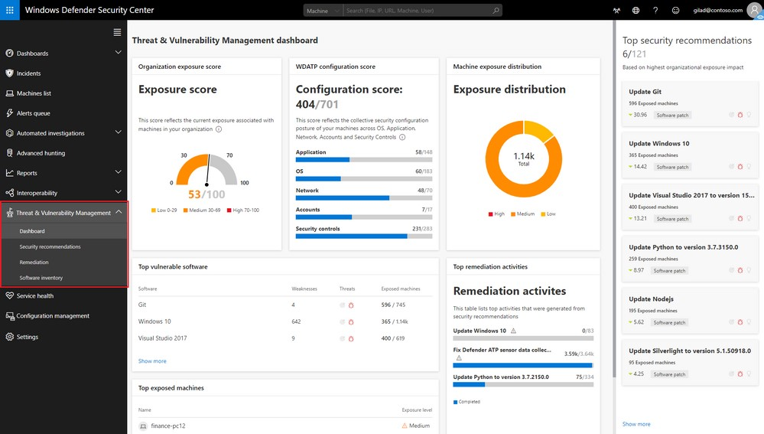

Windows Advanced Threat Protection consistently performs real-time analysis on endpoints. It retains visibility over all software in a device. It is constantly working on identifying and assessing any security vulnerabilities that might exist in any of the applications on your device.

With Windows Defender Advanced Threat Protection, you can see your overall exposure score, vulnerable software and machines in your network, and what you can do to remediate the issues.

When it discovers any weakness or vulnerability in any device, it promptly alerts you and provides recommendations to remediate it.

# Attack surface reduction

We can reduce the risk of a potential threat by minimizing areas where cyberattacks can take place. This can be done through various controls put in place by Windows Defender for

Endpoint, such as only allowing applications marked as ‘trusted’ to run on the device, allowing you to restrict certain behaviors in files and applications, as well as preventing untrusted websites, applications and files from accessing all areas in the device.

# Next generation protection

Windows Defender for Endpoint leverages Microsoft’s sophisticated technology and ongoing research in machine learning and threat resistance to provide you with behavior-based antivirus protection, cloud-delivered blocking, and constant product updates.

# Endpoint detection and response

Being a post-breach solution, Windows Defender Advanced Threat Protection offers endpoint detection and response (EDR) capabilities that identify and warn you about suspicious activities.

Once suspicious activity is detected in your network, you will immediately be alerted and provided with data to investigate the threat and make an informed decision about your next steps.

The Defender for Endpoint dashboard gives you access to in-depth data and analysis of different aspects of your security system from a centralized portal.

The endpoint detection and response in Windows Defender for Endpoint primarily consist of the following features and capabilities:

* **Alerts:** When a threat is detected, you will instantly receive an alert in your dashboard, along with basic information such as what the threat is, which device it has been found in, how severe it is, etc.
* **Investigation:** Your security team can investigate the threat further through features such as a timeline of events, which gives you a complete history of the threat since it arrived in your system, along with the list of machines that it has infected.
* **Remediation:** You will also be provided with a set of recommended next steps based on the behavior of the threat, and you can choose which action you would like to take.

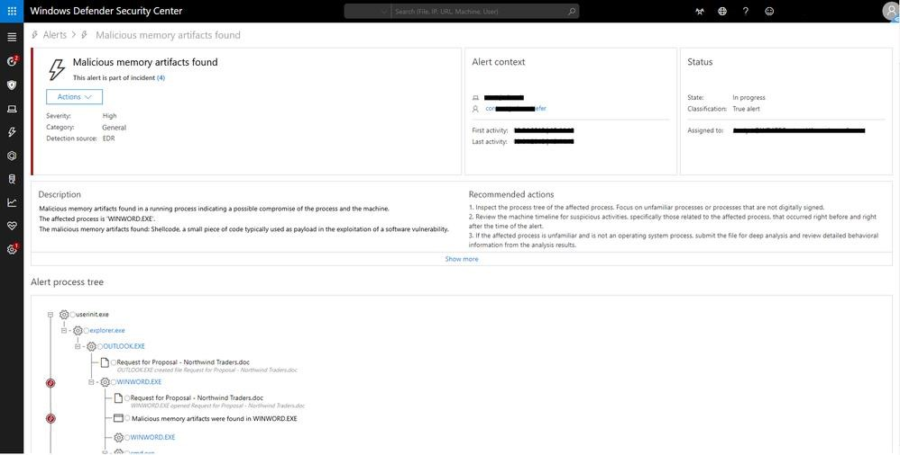

**Observation :** Thus,Windows Defender has been successfully analyzed.

**EXPERIMENT NO 2**

**Microsoft Security Essentials**

**Aim:** To Protect PC using Microsoft Security Essentials.

**Description**

To install Microsoft Security Essentials on Windows 7, follow these steps.

# Instructions

Identify If You Have a 32-bit or 64-bit Version

1. Open the System Properties by selecting the Start button, right-clicking Computer, and then selecting Properties.

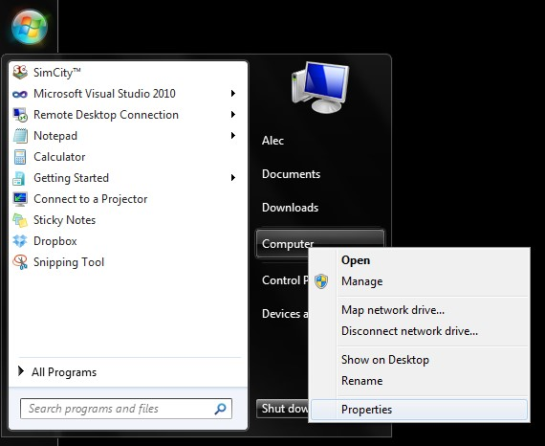

1. Under the System heading, you can view the system type.

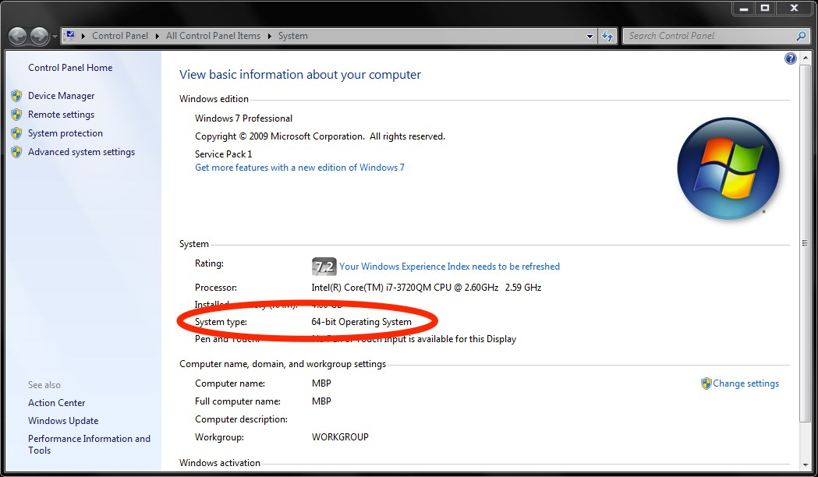

# Install Security Essentials

Once you have determined which operating systems version you have installed, download and install the corresponding version of Microsoft Security Essentials.

1. Download Microsoft Security Essentials from the Microsoft site.

* If your computer is running a 64-bit operating system, download the ENUS\amd64\MSEInstall.exe option.
* If your computer is running a 32-bit operating system, download the ENUS\x86\MSEInstall.exe option.

1. Once the download finishes, double-click the file to run the installer. You may get a popup box asking you to "allow the following program to make changes to this computer." Select Yes.

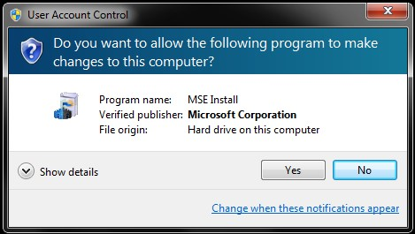

1. Once the installer extracts and runs, select Next

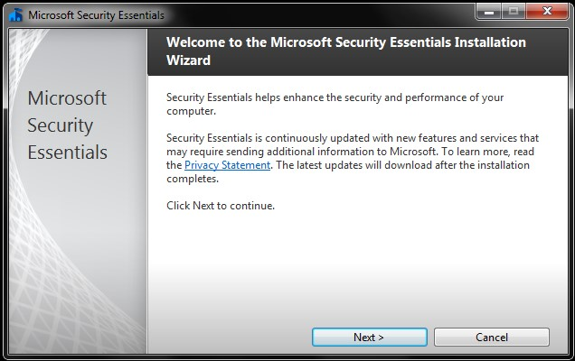

* Read through the Software License Terms, and select I Accept.
* Select Join the Customer Experience Improvement Program and then Next.
* Check the box for If no firewall is turned on, turn on Windows Firewall and select Next.
* Confirm that you don't have any other anti-virus programs installed, then select Install.
* When the program successfully installs, you should see the message, You have successfully completed the Security Essentials Installation Wizard.

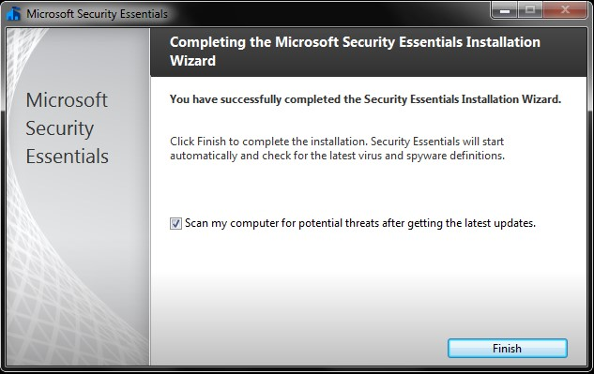

9. Select Finish, and allow Microsoft Security Essentials to perform an initial scan of your computer.

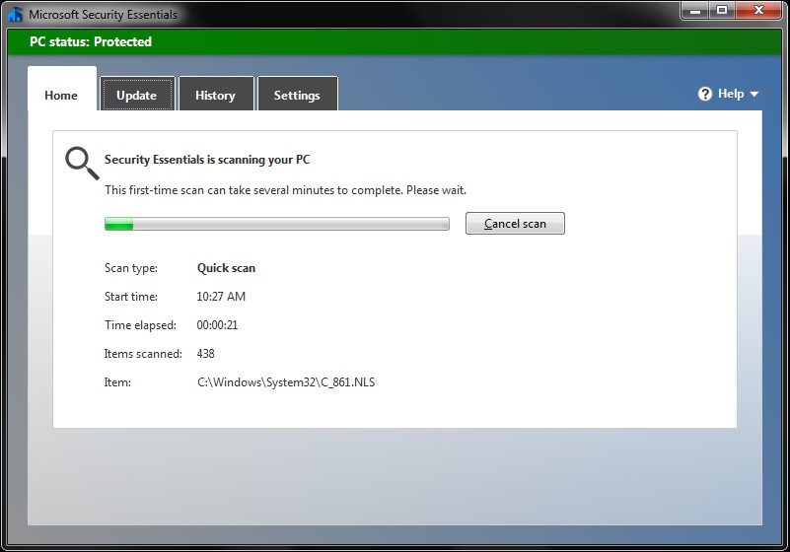

**Observation:** Microsoft Security Essentials scanned for virus and protect the system from intruders

# NMAP-VULNERABILITY SCANNER

**AIM:**To scan vulnerabilities using nmap in windows operating system

**DESCRIPTION:**

Nmap vulnerability scanning is the process of using Nmap to scan for and identify known vulnerabilities. The goal of Nmap vulnerability scanning is to gather information about a target host, system, network, or an information technology asset, test it for weaknesses, attempt to exploit those weaknesses, and report on the findings so appropriate security measures can be taken to eliminate any reported problems. Nmap vulnerability scanning may also be conducted to check the effectiveness of an organization’s security policy, adherence to compliance regulations, company-wide awareness of security measures, and the ability of an organization to flag and respond to security threats and violations.

Nmap is capable of:

* Scan Active IPs

Get detailed reporting on every IP on your network to figure out if a certain IP address is compromised and needs further investigation. Nmap can flag compromised IPs and report on whether they’re being used by a legitimate network service or a hacker.

* Scan Your Entire Network

Nmap can help you visualize and map out your entire local network. It can also show you a list of active live hosts, available ports, and the operating systems running on every device connected.

* Scan for Vulnerabilities

In addition to a number of network scanning functions, Nmap can also be used to identify vulnerabilities in your network. The tool gives you a frontrow view of what attackers would see if they attempt to infiltrate your network defenses. This can help you prepare better for any future cybersecurity threats.

* Visualize Your Network

Nmap is a command-line tool. But it has a graphical user interface called Zenmap that can help you visually map your network so you can understand it better and prepare reports that are easier to understand.

**PROCEDURE**

The primary uses of Nmap can be broken into three core processes.

* First, the program gives you detailed information on every IP active on your networks, and each IP can then be scanned. This allows administrators to check whether an IP is being used by a legitimate service, or by an external attacker.
* Secondly, Nmap provides information on your network as a whole. It can be used to provide a list of live hosts and open ports, as well as identifying the OS of every connected device. This makes it a valuable tool in ongoing system monitoring, as well as a critical part of pentesting.
* Thirdly, Nmap has also become a valuable tool for users looking to protect personal and business websites. Using Nmap to scan your own web server, particularly if you are hosting your website from home, is essentially simulating the process that a hacker would use to attack your site.

**OBSERVATION**

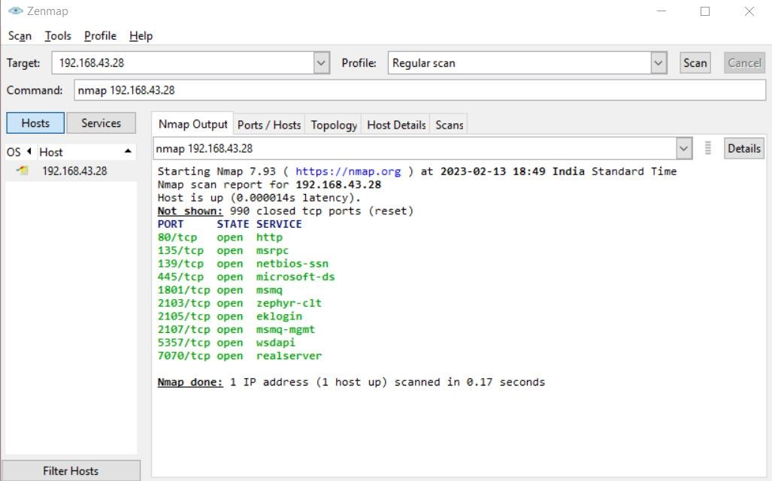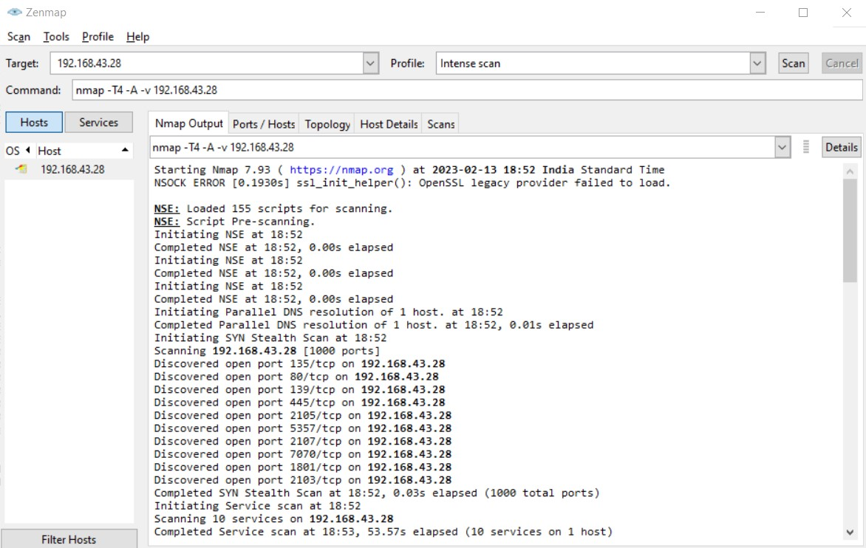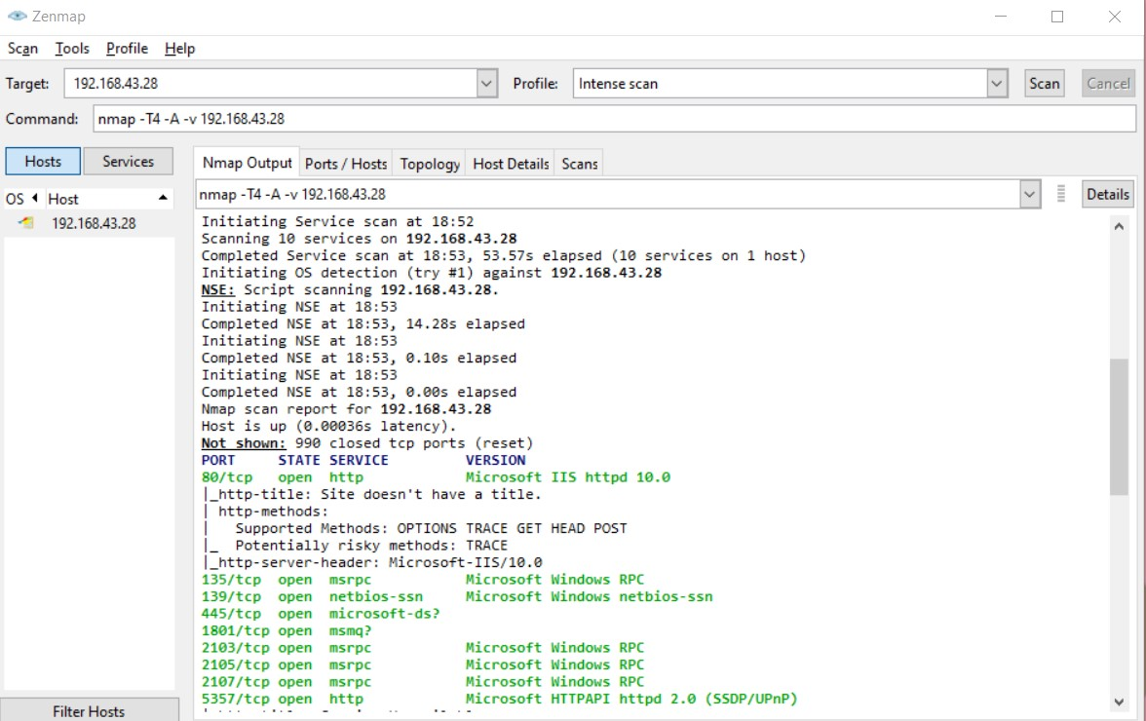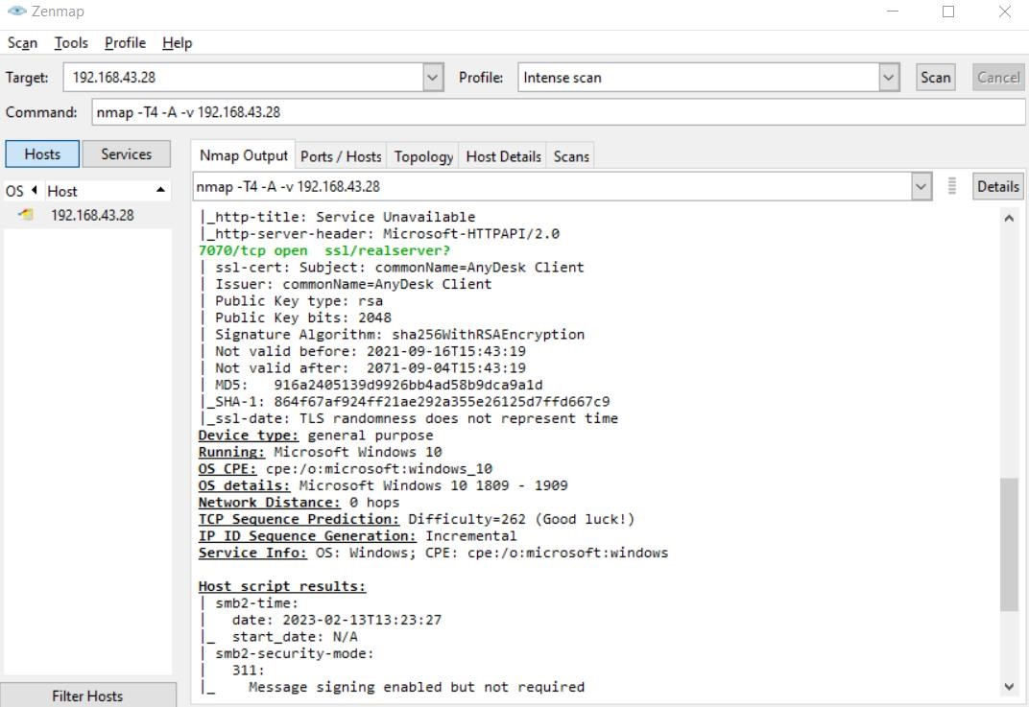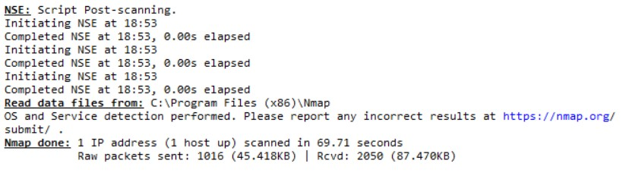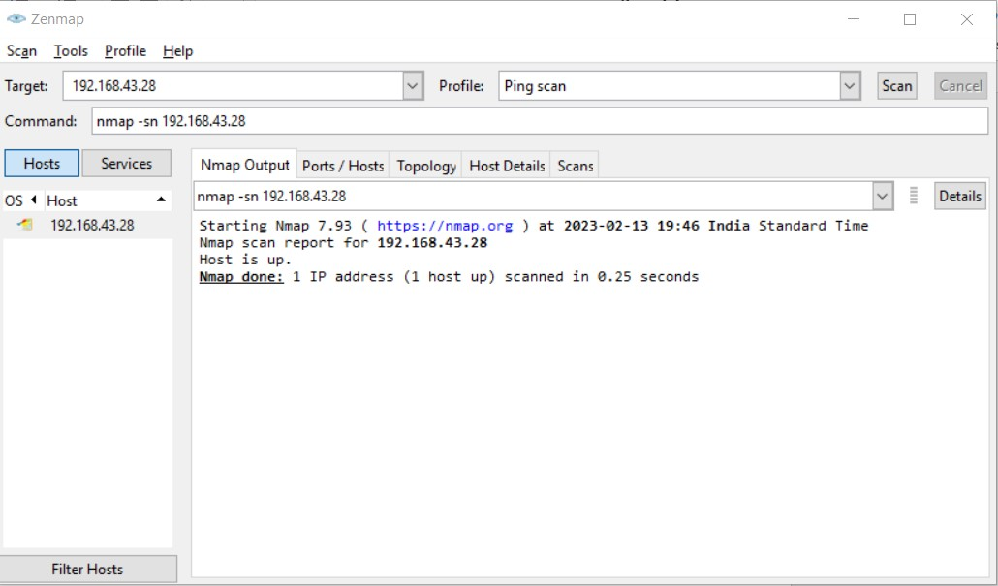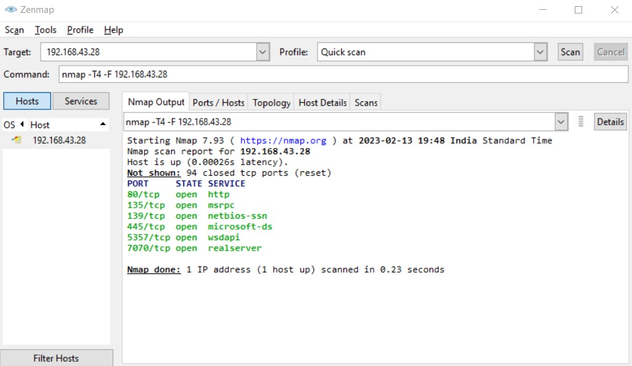

# Nmap Command in Linux

**AIM:**

To familiarize working of nmap in linux

**DESCRIPTION:**

Nmap is Linux command-line tool for network exploration and security auditing. This tool is generally used by hackers and cybersecurity enthusiasts and even by network and system administrators. It is used for the following purposes:

* Real time information of a network
* Detailed information of all the IPs activated on your network
* Number of ports open in a network
* Provide the list of live hosts
* Port, OS and Host scanning

**PROCEDURE:**

• Installing Nmap

## sudo apt-get install nmap

* To scan a System with Hostname and IP address. First, Scan using Hostname

***nmap*** [***www.geeksforgeeks.org***](http://www.geeksforgeeks.org/)

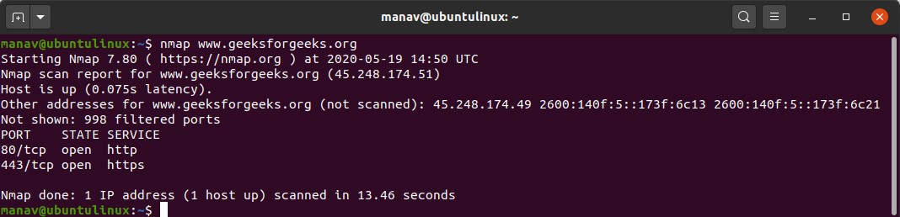

* Now let’s Scan using IP Address ***nmap 172.217.27.174***

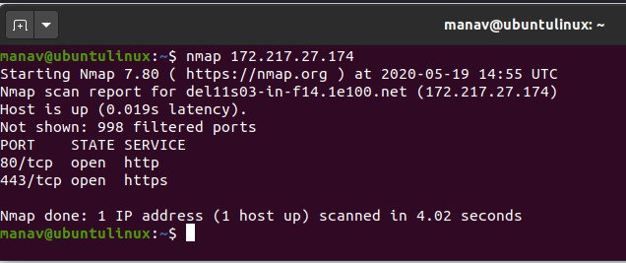

The nmap command allows scanning a system in various ways. In this we are performing a scan using the hostname as “geeksforgeeks” and IP address “172.217.27.174”, to find all open ports, services, and MAC addresses on the system.

* To scan using “-v” option.

## nmap -v www.geeksforgeeks.org

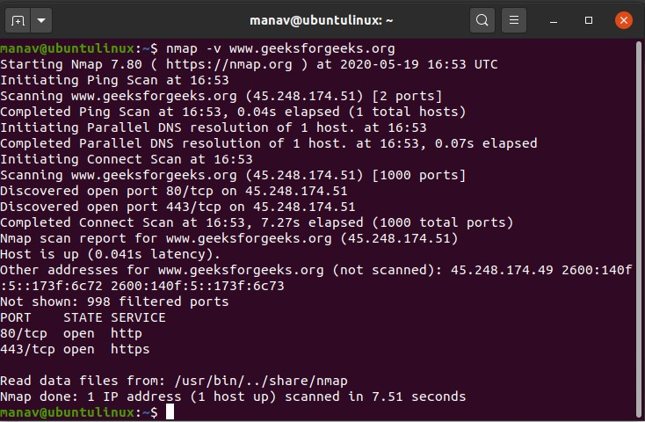

It is used to get more detailed information about the remote machines.

• To scan multiple hosts

## nmap 103.76.228.244 157.240.198.35 172.217.27.174

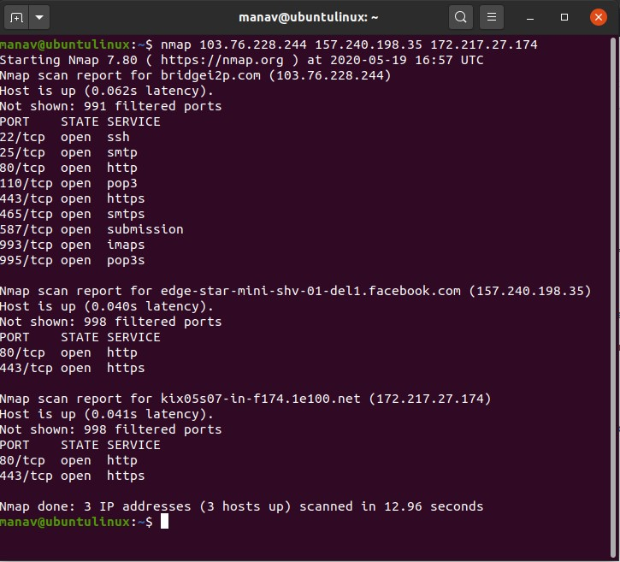

We can scan multiple hosts by writing IP addresses or hostnames with nmap.

* To scan whole subnet ***nmap 103.76.228.\****

We can scan a whole subnet or IP range with nmap by providing “*” with it. It will scan a whole subnet and give the information about those hosts which are Up in the Network.

* To scan specific range of IP address ***nmap 192.168.29.1-20***

We can specify the range of IP addresses. This command will scan IP address 192.168.29.1 to 192.168.29.20 .

* To scan to detect firewall settings.

### sudo nmap -sA 103.76.228.244

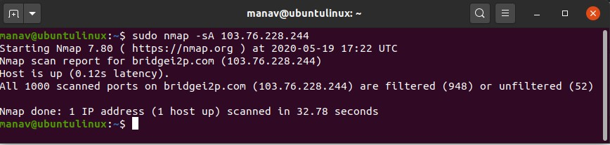

Detecting firewall settings can be useful during penetration testing and vulnerability scans.

To detect it we use “-sA” option. This will provide you with information about firewall being active on the host. It uses an ACK scan to receive the information.

• To identify Hostnames

### sudo nmap -sL 103.76.228.244

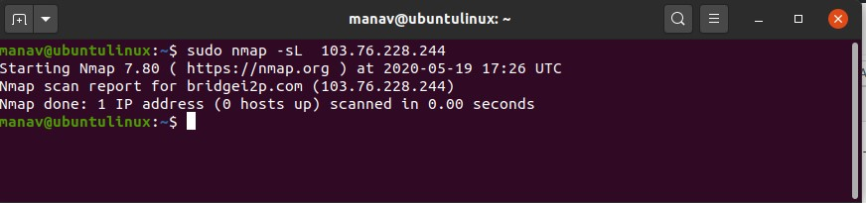

We use “sL” option to find hostnames for the given host by completing a DNS query for each one. In addition to this “-n” command can be used to skip DNS resolution, while the “-R” command can be used to always resolve DNS.

• To scan from a file

### nmap -iL input.txt

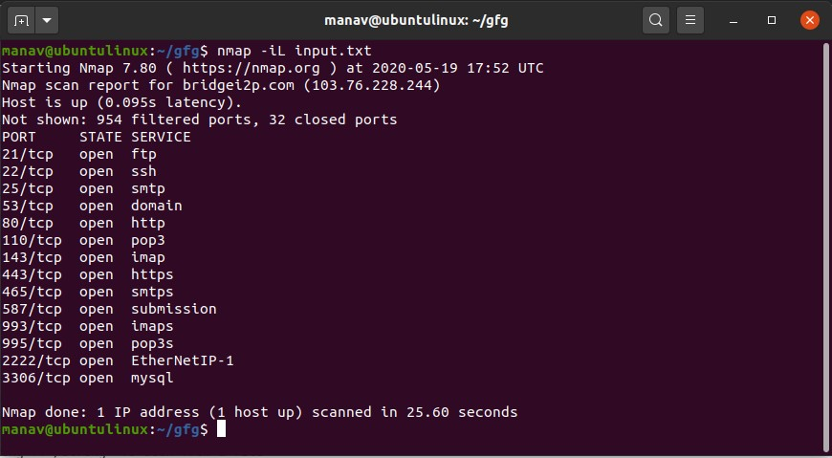

If we have a long list of addresses that we need to scan, we can directly import a file through the command line. It will produce a scan for the given IP addresses.

* To get some help ***nmap -h***

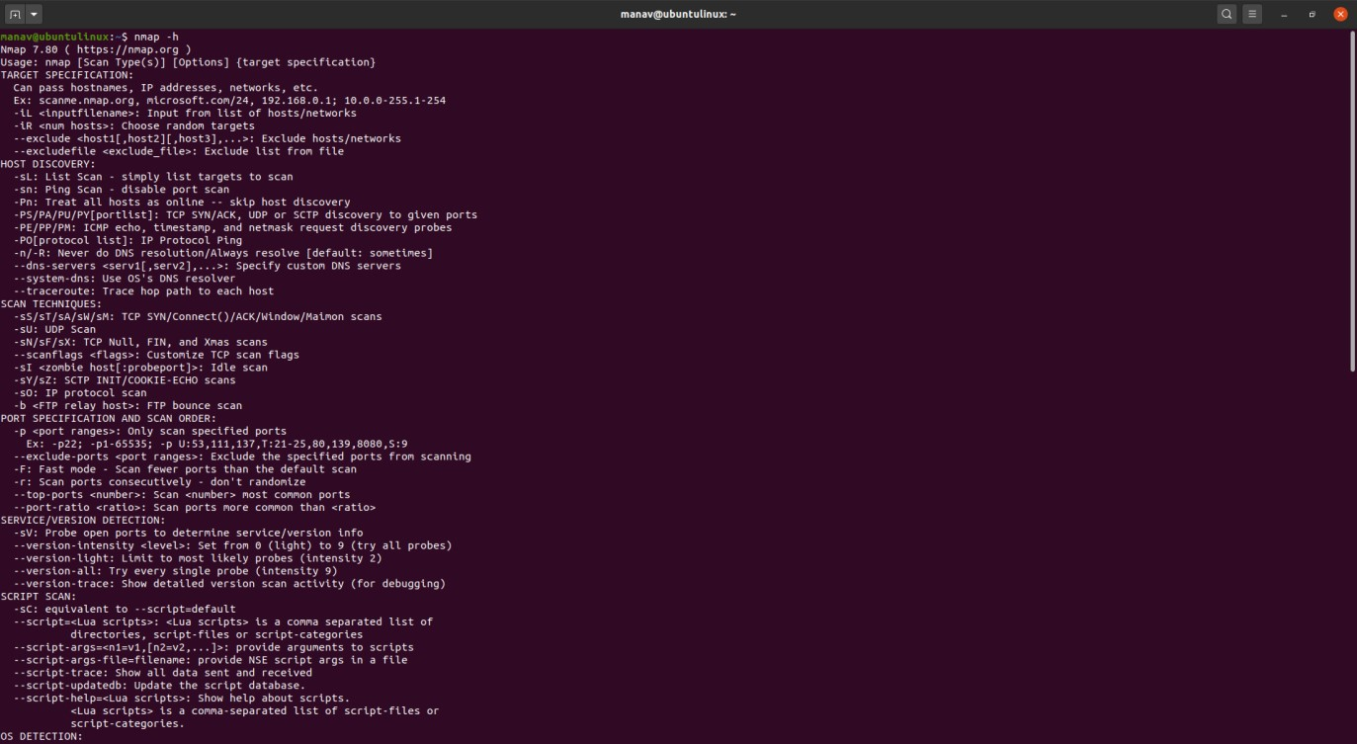

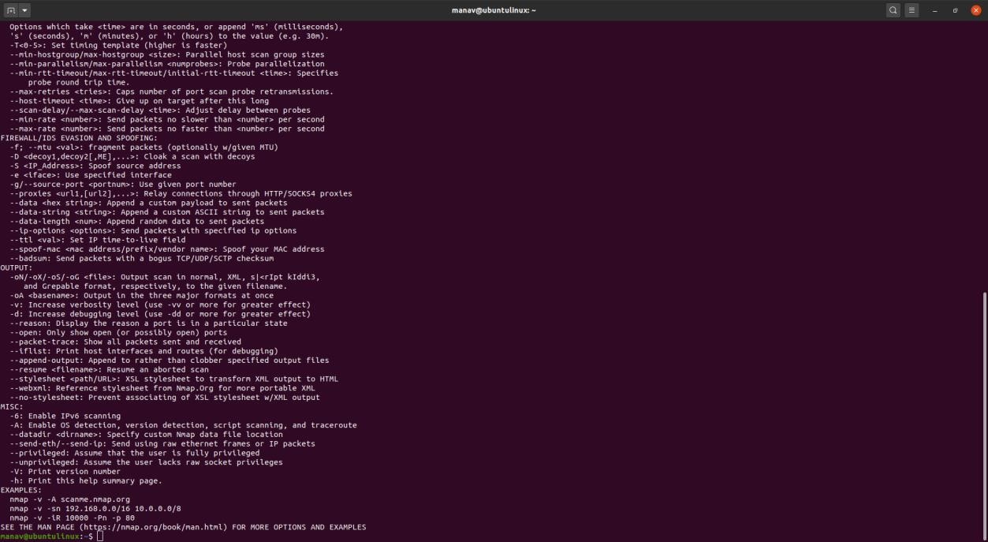

We use the “-h” option if we have any questions about nmap or any of the given commands. It shows the help section for nmap command, including giving information regarding the available flags.

* Here -sS flag is used for TCP SYN Scan, which is a stealthy and efficient method of scanning for open ports on a target system.

### nmap -sS <Domain Name>

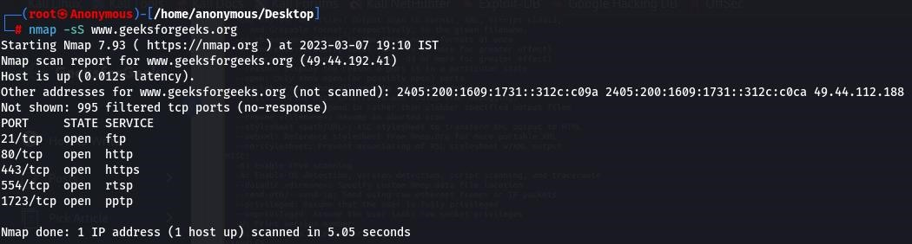

* Here “-oG” flag can be used to store the nmap result in to specific file. ***nmap -sS <Domain Name> -oG <file-path>***

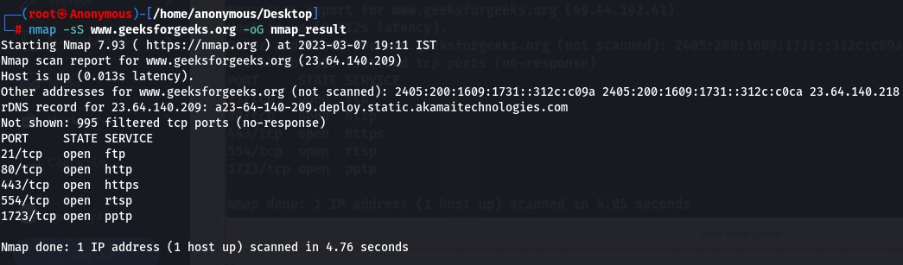

* The “-sU” flag is used with nmap to perform a UDP scan, which allows the user to discover open UDP ports and services on a target system.

### nmap -sU <Domain Name>

• The “-sn” flag is used with nmap to perform a ping scan, which sends ICMP requests to a target host or network to determine hosts is up or not.

### nmap -sn <Domain Name>

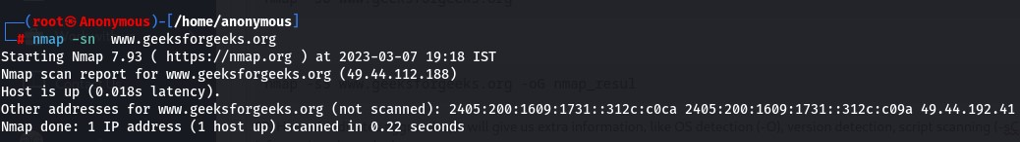

• The “-p” flag is used with nmap to perform scan on a specific port or range of ports. ( In our case it will scan port 80,443 and 21 )

### nmap -p 80 443 21 <Domain Name>

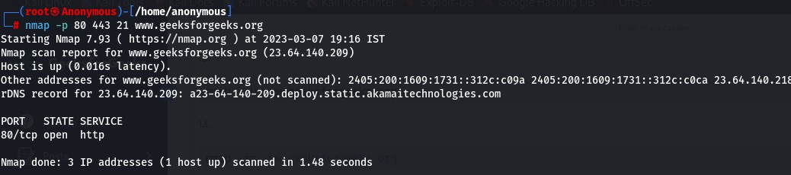

• We can also specify the range of ports to scan on a network. ( In this case it will scan all the ports in the range of 1 to 80 )

### nmap -p 1-80 <Domain Name>

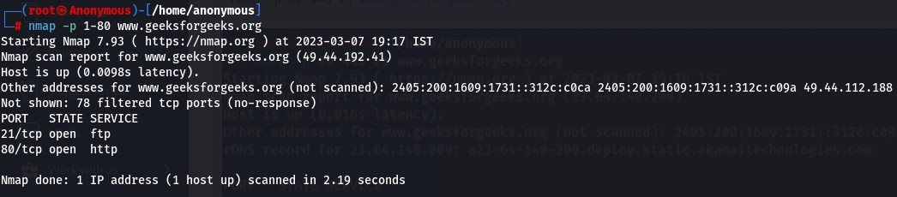

• Here -A indicates aggressive, it will give us extra information, like OS detection (-O), version detection, script scanning (-sC), and traceroute (–traceroute). It even provides a lot of valuable information about the host.

### nmap -A <Domain Name>

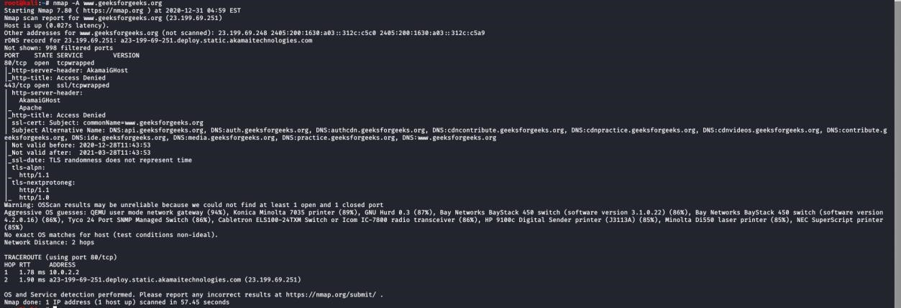

• Using this command we can discover the target hosting service or identify additional targets according to our needs for quickly tracing the path.

### nmap --trace out <Domain Name>

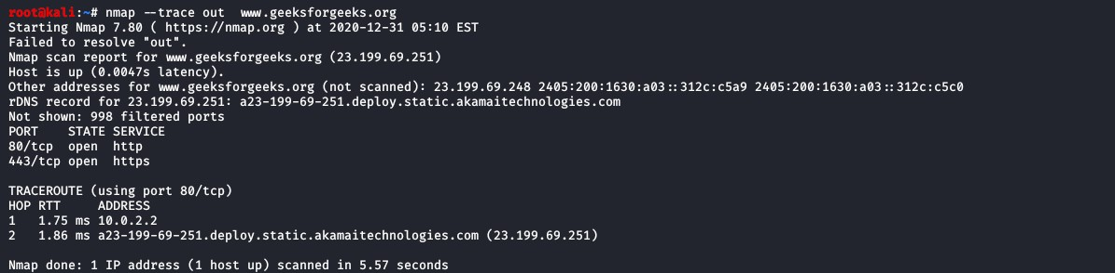

• Here it will display the operating system where the domain or ip address is running, but will not display the exact operating system available on the computer. It will display only the chance of operating system available in the computer. The command will just guess the running operating system (OS) on the host.

### nmap -O <Domain Name>

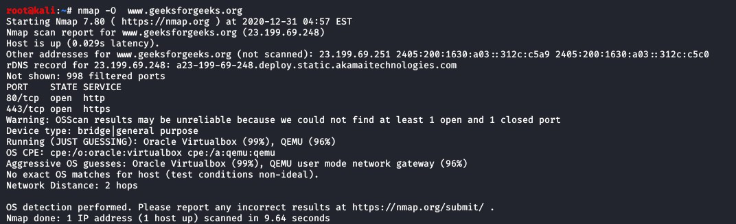

# WIRESHARK

**AIM:**

To provide deeper understanding of Network Protocol Analysis using Wireshark

**DESCRIPTION:**

Wireshark is an open-source packet analyzer, which is used for education, analysis, software development, communication protocol development, and network troubleshooting.It is used to track the packets so that each one is filtered to meet our specific needs. It is commonly called as a sniffer, network protocol analyzer, and network analyzer. It is also used by network security engineers to examine security problems.

Wireshark is a free to use application which is used to apprehend the data back and forth. It is often called as a free packet sniffer computer application. It puts the network card into an unselective mode, i.e., to accept all the packets which it receives.

Wireshark can be used in the following ways:

* It is used by network security engineers to examine security problems.
* It allows the users to watch all the traffic being passed over the network.
* It is used by network engineers to troubleshoot network issues.
* It also helps to troubleshoot latency issues and malicious activities on your network.
* It can also analyze dropped packets.
* It helps us to know how all the devices like laptop, mobile phones, desktop, switch, routers, etc., communicate in a local network or the rest of the world.

Wireshark is similar to tcpdump in networking. Tcpdump is a common packet analyzer which allows the user to display other packets and TCP/IP packets, being transmitted and received over a network attached to the computer. It has a graphic end and some sorting and filtering functions. Wireshark users can see all the traffic passing through the network.

Wireshark can also monitor the unicast traffic which is not sent to the network's MAC address interface. But, the switch does not pass all the traffic to the port. Hence, the promiscuous mode is not sufficient to see all the traffic. The various network taps or port mirroring is used to extend capture at any point.

Port mirroring is a method to monitor network traffic. When it is enabled, the switch sends the copies of all the network packets present at one port to another port.

Features of Wireshark

* It is multi-platform software, i.e., it can run on Linux, Windows, OS X, FreeBSD, NetBSD, etc.
* It is a standard three-pane packet browser.
* It performs deep inspection of the hundreds of protocols.
* It often involves live analysis, i.e., from the different types of the network like the Ethernet, loopback, etc., we can read live data.
* It has sort and filter options which makes ease to the user to view the data.
* It is also useful in VoIP analysis.
* It can also capture raw USB traffic.
* Various settings, like timers and filters, can be used to filter the output.
* It can only capture packet on the PCAP (an application programming interface used to capture the network) supported networks.
* Wireshark supports a variety of well-documented capture file formats such as the PcapNg and Libpcap. These formats are used for storing the captured data.
* It is the no.1 piece of software for its purpose. It has countless applications ranging from the tracing down, unauthorized traffic, firewall settings, etc.

**PROCEDURE**

Below are the steps to install the Wireshark software on the computer:

* Open the web browser.
* Search for 'Download Wireshark.'
* Select the Windows installer according to your system configuration, either 32-bt or 64-bit. Save the program and close the browser.
* Now, open the software, and follow the install instruction by accepting the license.

The Wireshark is ready for use.

On the network and Internet settings option, we can check the interface connected to our computer.If you are Linux users, then you will find Wireshark in its package repositories.By selecting the current interface, we can get the traffic traversing through that interface. The version used here is 3.0.3. This version will open as:

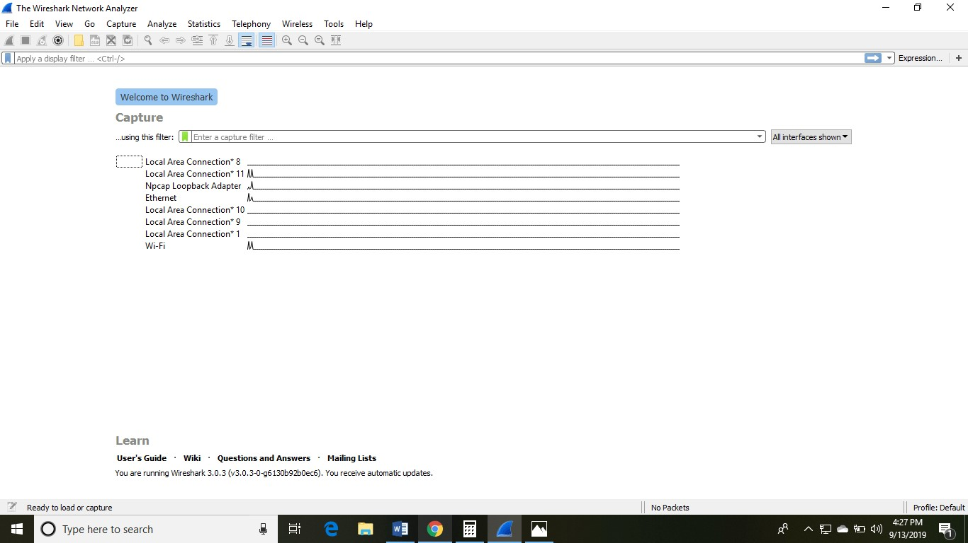

The Wireshark software window is shown above, and all the processes on the network are carried within this screen only. The options given on the list are the Interface list options. The number of interface options will be present. Selection of any option will determine all the traffic. For example, from the above fig. select the Wi-Fi option. After this, a new window opens up, which will show all the current traffic on the network. Below is the image which tells us about the live capture of packets and our Wireshark will look like:

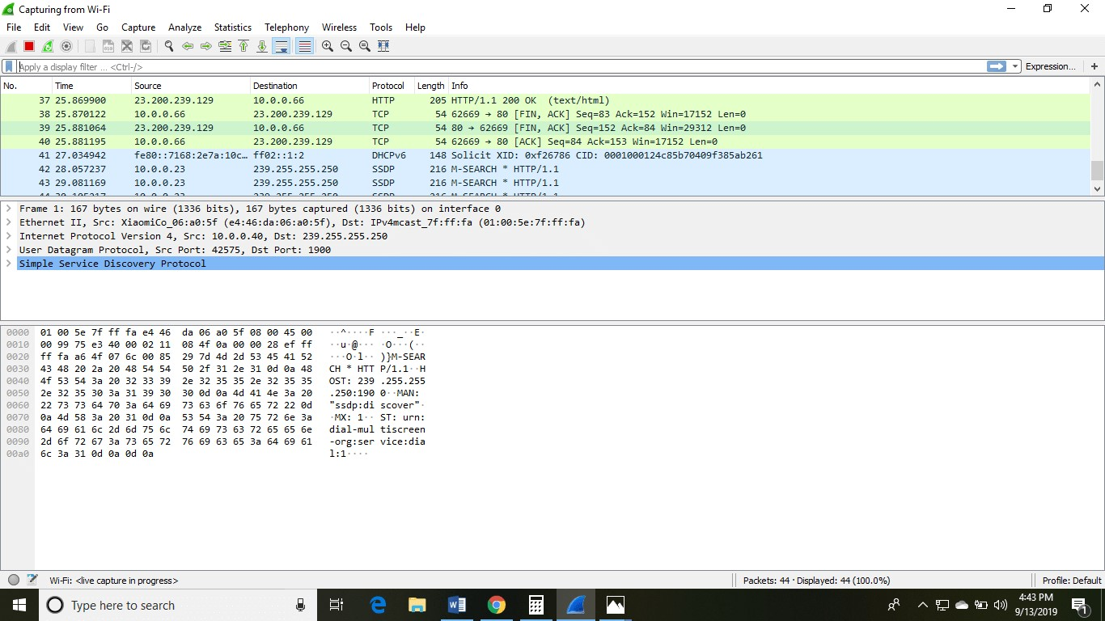

The above arrow shows the packet content written in hexadecimal or the ASCII format. And the information above the packet content, are the details of the packet header.

It will continue listening to all the data packets, and you will get much data. If you want to see a particular data, then you can click on the red button. The traffic will be stationary, and you can note the parameters like time, source, destination, the protocol being used, length, and the Info. To view in-depth detail, you can click on that particular address; a lot of the information will be displayed below that.

There will be detailed information on HTTP packets, TCP packets, etc. The red button is shown below:

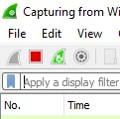

The screen/interface of the Wireshark is divided into five parts:

* First part contains a menu bar and the options displayed below it. This part is at the top of the window. File and the capture menus options are commonly used in Wireshark. The capture menu allows to start the capturing process. And the File menu is used to open and save a capture file.
* The second part is the packet listing window. It determines the packet flow or the captured packets in the traffic. It includes the packet number, time, source, destination, protocol, length, and info. We can sort the packet list by clicking on the column name.
* Next comes the packet header- detailed window. It contains detailed information about the components of the packets. The protocol info can also be expanded or minimized according to the information required.
* The bottom window called the packet contents window, which displays the content in ASCII and hexadecimal format.
* At last, is the filter field which is at the top of the display. The captured packets on the screen can be filtered based on any component according to your requirements. For example, if we want to see only the packets with the HTTP protocol, we can apply filters to that option. All the packets with HTTP as the protocol will only be displayed on the screen, shown below:

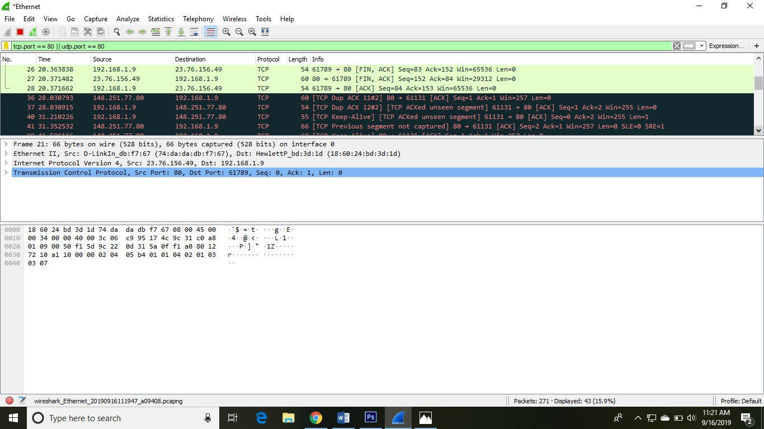

You can also select the connection to which your computer is connected. For example, in this PC, we have chosen the current network, i.e., the ETHERNET.

After connecting, you can watch the traffic below:

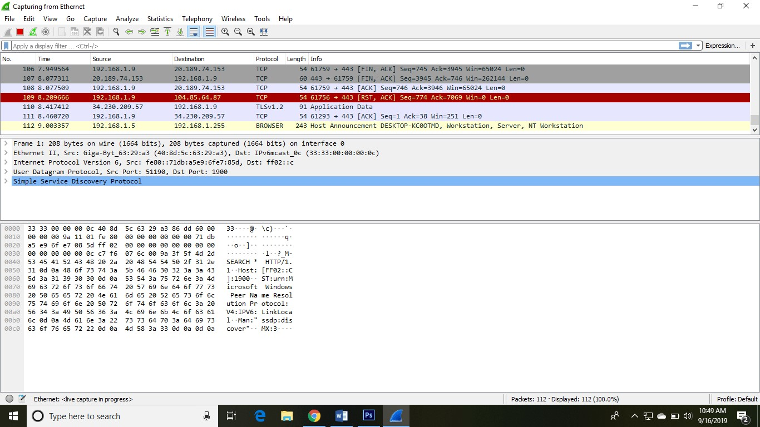

In view option on the menu bar, we can also change the view of the interface. You can change the number of things in the view menu. You can also enable or disable any option according to the requirements.

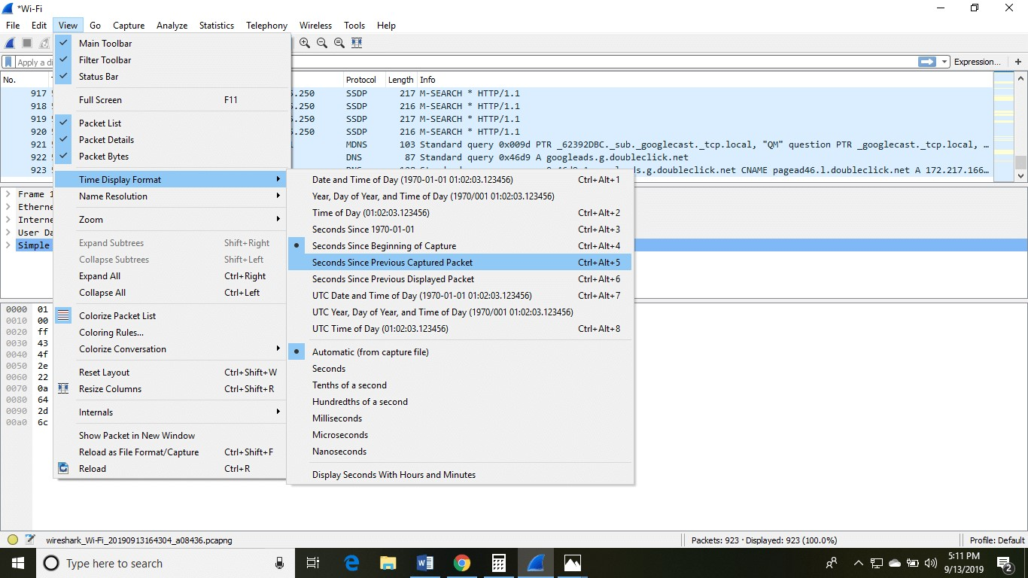

There is a filter block below the menu bar, from where a large amount of data can be filtered. For example, if we apply a filter for HTTP, only the interfaces with the HTTP will be listed.

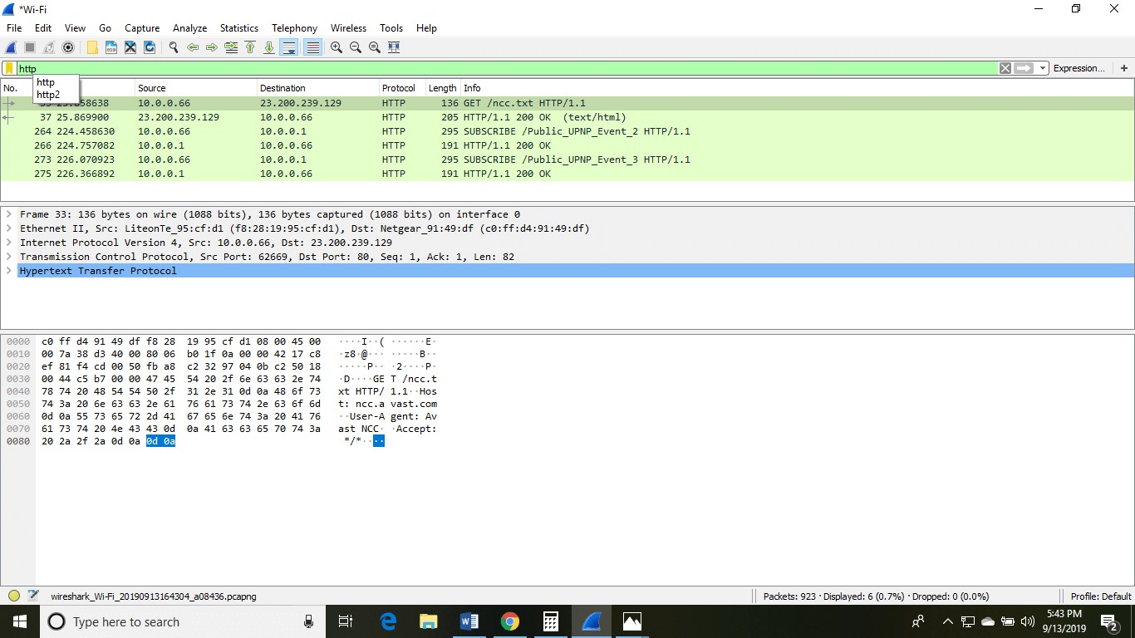

If you want to filter according to the source, right-click on the source you want to filter and select 'Apply as Filter' and choose '...and filter.'

Steps for the permanent colorization are: click on the 'View' option on the menu bar and select 'Coloring Rules.' The table will appear like the image shown below:

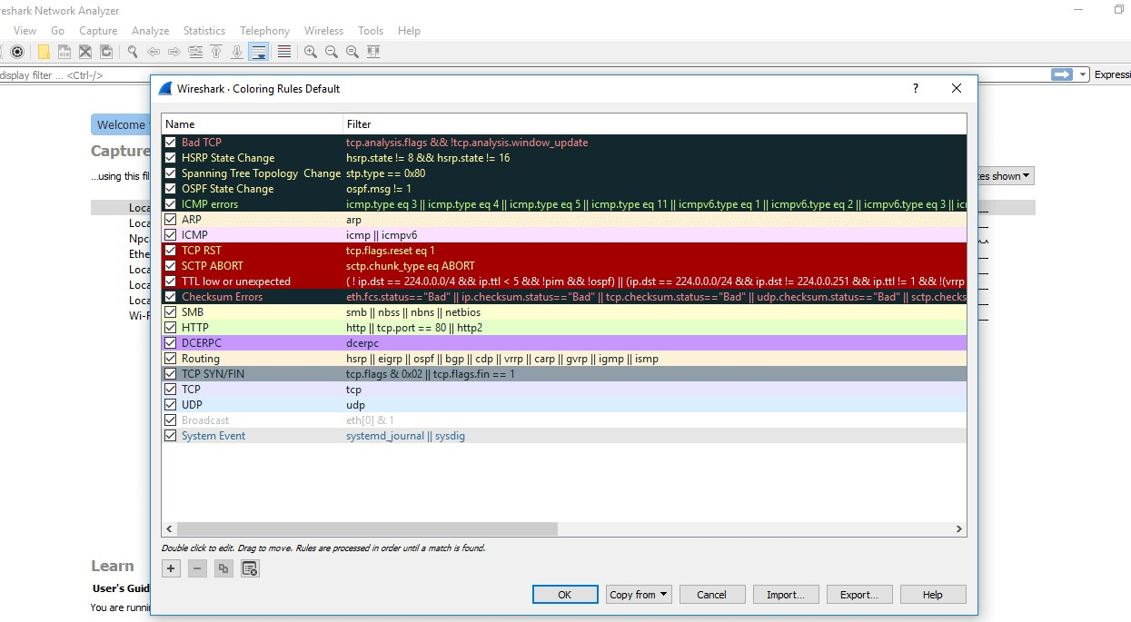

For the network administrator job, advanced knowledge of Wireshark is considered as the requirements. So, it is essential to understand the concepts of the software. It contains these 20 default coloring rules which can be added or removed according to the requirements. Select the option 'View' and then choose 'Colorize Packet List,' which is used to toggle the color on and off. Whenever we type any commands in the filter command box, it turns green if your command is correct. It turns red if it is incorrect or the Wireshark does not recognize your command.

If you have a Linux system, you’d install Wireshark using the following sequence (notice that you’ll need to have root permissions):

***$ sudo apt-get install wireshark***

***$ sudo dpkg-reconfigure wireshark-common***

***$ sudo usermod -a -G wireshark $USER***

## $ newgrp wireshark

Once you have completed the above steps, you then log out and log back in, and then start Wireshark:

## $ wireshark

Wireshark tries to help you identify packet types by applying common-sense color coding. The table below describes the default colors given to major packet types.

**Color in**

**Wireshark**

**Packet Type**

Light purple

TCP

Light blue

UDP

Black

Packets with errors

Light green

HTTP traffic

Light yellow

Windows

-

specific traffic, including Server Message Blocks

(

SMB) and NetBIOS

**Color in**

**Wireshark**

**Packet Type**

Dark yellow

Routing

Dark gray

TCP SYN, FIN and ACK traffic

In Wireshark, just go to Statistics >> I/O Graph, and you’ll see a graph similar to the one below:

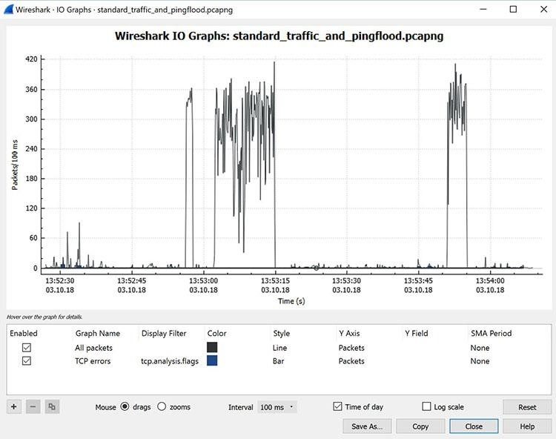

Figure : Viewing the input/output traffic graph in Wireshark

This particular graph is showing typical traffic generated by a home office. The spikes in the graph are bursts of traffic that were caused by generating a [Distributed Denial of Service (DDoS) attack](https://www.comptia.org/content/guides/what-is-ddos-protection-tools-stopping/) using a few Linux systems.

In this case, three major traffic bursts were generated. Many times, cybersecurity pros use Wireshark as a quick and dirty way to identify traffic bursts during attacks.

It’s also possible to capture the amount of traffic generated between one system and another. If you go to Statistics and then select Conversations, you will see a summary of conversations between end points, as shown below in Figure.

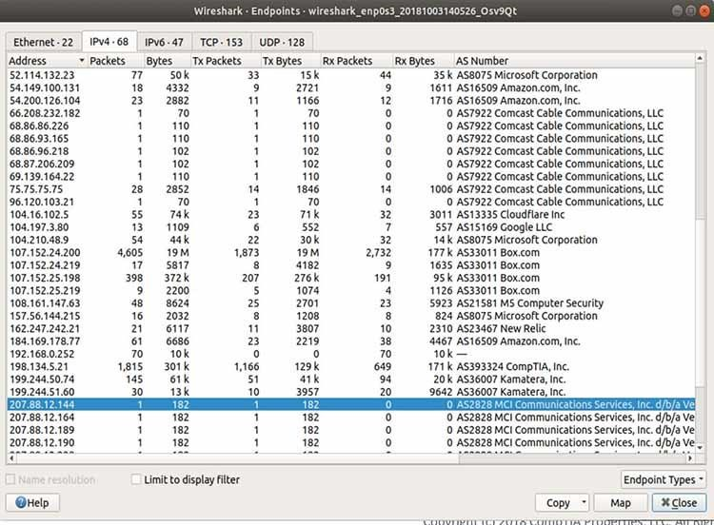

Figure: Viewing endpoint conversations in Wireshark

In the above case, Wireshark was used to see if an old piece of equipment from MCI communications that was running on a client’s network could be traced.

It turned out that the client didn’t know this device was even on the network. Thus, it was removed, helping to [make the network a bit more secure.](https://www.comptia.org/content/guides/network-security-basics-definition-threats-and-solutions) Notice, also, that this network connection is experiencing a lot of traffic to Amazon (administering a server in AWS at the time) and Box.com (using Box for system backup at the time).

In some cases, it is even possible to use Wireshark to identify the geographic location of source and destination traffic. If you click on the Map button at the bottom of the screen , Wireshark will show you a map, providing its best guess of the location of the IP addresses you’ve identified.

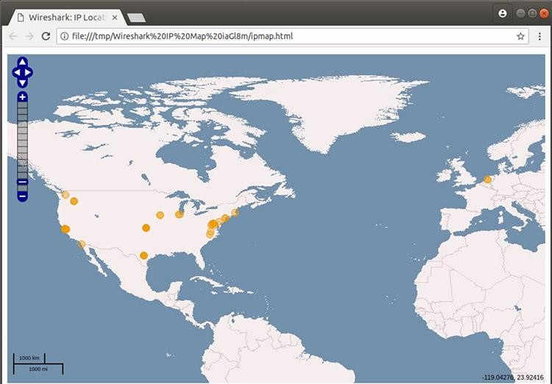

Figure: Viewing geographic estimations in Wireshark

Because IPv4 addresses can be easily spoofed, you can’t rely completely on this geographical information. But it can be fairly accurate.

You can apply Wireshark filters in two ways:

1. In the Display Filter window, at the top of the screen
2. By highlighting a packet (or a portion of a packet) and right-clicking on the packet

Wireshark filters use key phrases, such as the following:

ip.addr

Specifies an IPv4 address

ipv6.addr

Specifies an IPv6 address

src

Source

-

where the packet came from

dst

Destination

-

where the packet is going

You can also use the following values:

&&

Means “and,” as in,

“Choose the IP address of 192.168.2.1 and 192.168.2.2”

==

Means “equals,” as in “Choose only IP address 192.168.2.1”

!

Means “not,” as in, do not show a particular IP address or source port

Valid filter rules are always colored green. If you make a mistake on a filter rule, the box will turn a vivid pink.

For example, let’s say you want to see packets that have only the IP address of 18.224.161.65 somewhere inside. You would create the following command line, and put it into the Filter window:

## ip.addr == 18.224.161.65

Figure shows the results of adding that filter:

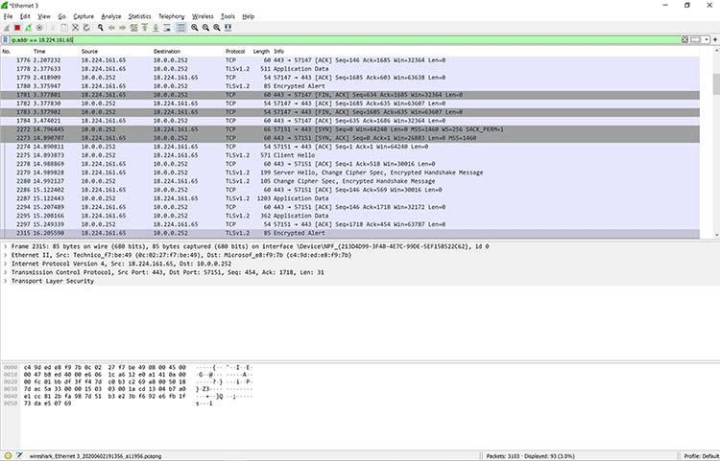

Figure: Applying a filter to a capture in Wireshark

Alternatively, you can highlight the IP address of a packet and then create a filter for it.

Once you select the IP address, right-click, and then select the Apply As Filter option.

You’ll then see a menu of additional options. One of those is called Selected. If you choose Selected, then Wireshark will create a filter that shows only packets with that IP address in it.

You can also decide to filter out a specific IP address using the following filter, also shown in Figure:

## !ip.addr==18.224.161.65

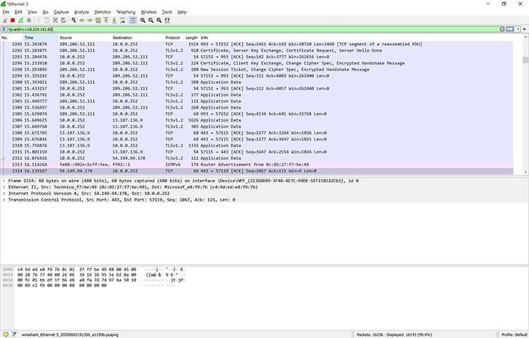

Figure: Filtering out a specific IP address in Wireshark

You’re not limited to just IPv4 addresses. For example, if you want to see if a particular computer is active and using an IPv6 address on your network, you can open up a copy of Wireshark and apply the following rule:

## ipv6.dst == 2607:f8b0:400a:15::b

This same rule is shown in Figure.

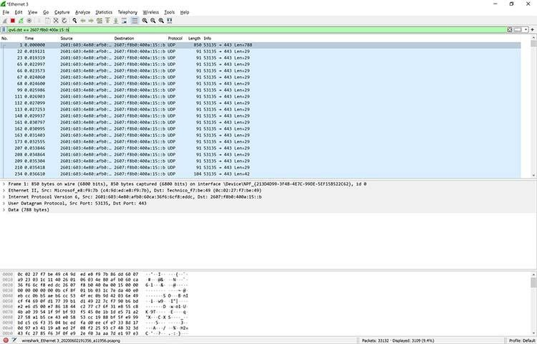

Figure: Applying an IPv6 filter in Wireshark

Clearly, this system is alive and well, talking on the network. There are so many possibilities.

Additional filters include:

tcp.port==8080

Filters packets to show a port of your own

choosing

–

in this case, port 8080

ip.src

!(

==

162.248.16.53)

Shows all packets except those originating

from 162.248.16.53

!(

==

ipv6.dst

2607:f8b0:400a:15::b)

Shows all packets except those going to the

IPv6 address of 2607:f8b0:400a:15::b

|  |  |
| --- | --- |
|  |  |
| ip.addr == 192.168.4.1  && ip.addr == 192.168.4.2 | Shows both 192.168.4.1 and 192.168.4.2 |
|  |  |
| http.request | Shows only http requests – useful when troubleshooting or visualizing web traffic |
|  |  |

**EXPERIMENT NO 3**

**XIAO STEGANOGRAPHY**

**Aim:** To hide the secret data from unauthorized users in order to prevent confidentiality, integrity and availability of data.

## XIAO STEGANOGRAPHY

Xiao Steganography is a tool which is used to hide the secret data from unauthorized users in order to prevent confidentiality, integrity and availability of data. .Xiao Steganography is free software that can be used to hide secret files in BMP images or in WAV files. Usage of this tool is easy, as it can be downloaded and used. Any BMP image or WAV file can be added to its interface. Then the file, which we want to hide, is added. Xiao also supports encryption. We can select from various algorithms like RC4, Triple DES, DES, Triple DES 112, RC2 and hashing SHA, MD4, MD2, MD5.

To read the hidden message from this file, we will have to use this software again. This software will read the file and will decode the hidden file from it. But we extract the hidden file from any other software other than Xiao, as it has been hidden or encrypted using Xiao only.

Following are the various steps that show encoding and decoding as achieved by Xiao:

A. Encoding/Encrypting using Xiao

1. Open Xiao tool to implement Steganography, as shown in Fig. 1. This is the first snapshot when the tool is opened after being downloaded.

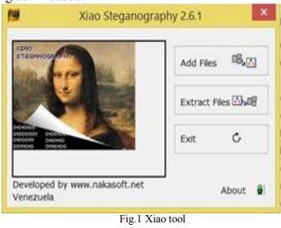

1. As shown in Fig. 2, cover image or the target file, as popularized by Xiao is selected. For this the Load Target File option should be clicked.

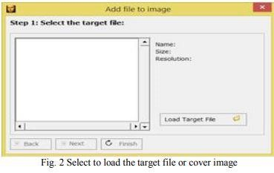

1. Fig. 3 depicts out target image. The secret message will be embedded in this target file. Select this target file to conceal our secret data.

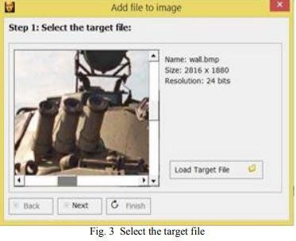

1. By selecting on Add File button in Fig. 4, we will be able to select our Secret file or confidential data, which will be embedded in our target file. The remaining size is mentioned in KB. This suggests the size available to add the secret data in the form of files.

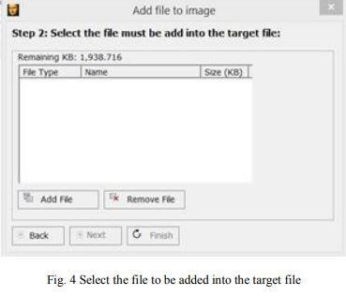

1. Fig. 5 shows that we are hiding an image called Koala. Further files can be embedded using the Add File option.

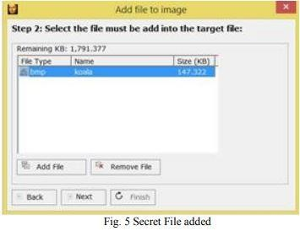

1. In Fig. 6, we need to select the encryption option and a password to provide double security of our confidential message/image. There are four hashing algorithms and five encryption algorithms available as depicted below:

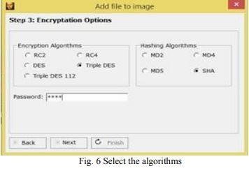

1. After applying the appropriate encryption algorithm and a strong password on our secret message, we can embed it in our target files as shown in Fig. 7. This snapshot depicts a progress bar exhibiting the merging of both the files i.e. Target File or Cover Image and our Secret image.

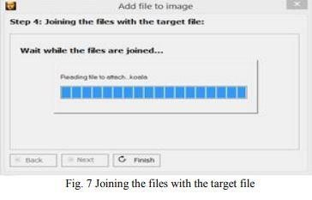

1. All the above seven steps accord with embedding process and Fig. 8 shows that steganography was successfully accomplished.

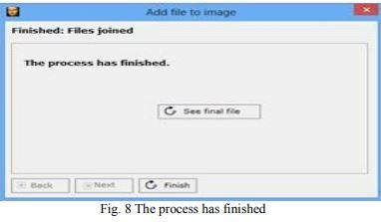

B. Encoding/Decrypting using Xiao 1) Now at the decoding end, if an authenticated user wants to extract the secret message from the target file or the cover image, then receiver needs to click on the Extract file option as shown in Fig. 9

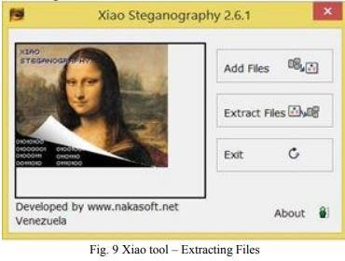

1. In Fig. 10, we need to select Source file. This is the same target file or cover image which was used for encoding the confidential data.

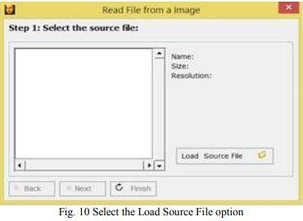

1. Fig. 11 shows the Cover Image or the target file. By clicking on Extracting Load file, we can extract our secret koala file.

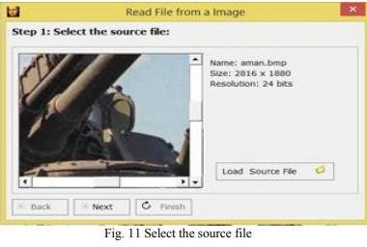

1. Fig. 12 depicts our embedded target file ready for decryption

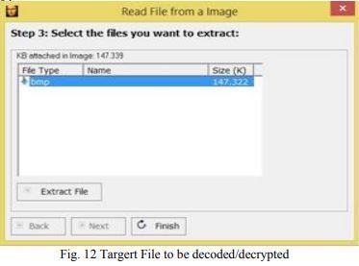

1. Here we can easily see our secret image koala which we embedded. This secret image is the actual message intended for the recipient which could be saved at any path using the Save As option as depicted in Fig. 13

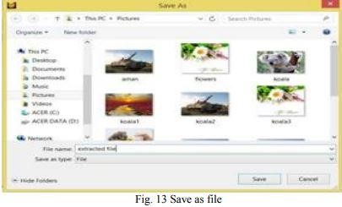

1. Fig. 14 shows the secret file had been extracted by the receiver successfully.

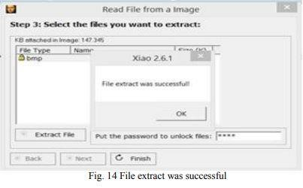

**Observation**: This tool hide and retrieve data successfully.

**STEGOSUITE**

**AIM:** To familiarize stegnography tools in linux

**DESCRIPTION**

With the rapid growth of network bandwidth and digital-communication techniques, the Internet is available to the majority of the population and it also becomes the common channel for transmitting many documents—for instance, video, image, text, and audio (in digital form). Many practices and methods have been developed to make the transmission of data more secure. The problem is that the focus of the current research is mainly on the better designing of data-hiding techniques used for transmitting secret data where digital images are selected as the cover-media. Unlike the other forms of communication, the process of steganography is defeated when the communication between sender and receiver is detected. Therefore, the first requirement for a good steganographic structure is it is undetectable.

Hiding secret information in Audio and Images: Many methods for hiding information in audio and images exist. These methods may include hiding information in unused space in file headers to hold “extra” information. Embedding techniques can range from the placement of indistinguishable information level, sometimes it includes manipulation of compression algorithms, and to the extent of modification of properties of the carrier. In audio file Steganography, small echoes or slight delays can be added or indistinct signals can be masked by sounds of higher amplitude.

Stegosuite: Stegosuite is a graphical steganography tool (this is the main difference between Stegosuite and Stegohide). It is used to hide secret data or information in image files. Stegosuite provides the facility of embedding text messages and multiple files of any type. To make the process of embedding more secure, the embedded data is encrypted using AES (Advanced Encryption Standard). Currently, the Stegosuite tool supports BMP, GIF, JPG, and PNG file types.

**PROCEDURE**

Installing Stegosuite: To install the Stegosuite tool in Kali Linux follow the below commands.

***sudo apt-get update -y***

***// Execute above command first then execute***

***// next command to avoid Archives***

### // Installation Error sudo apt-get install stegosuite

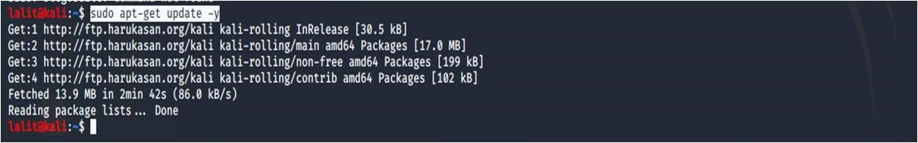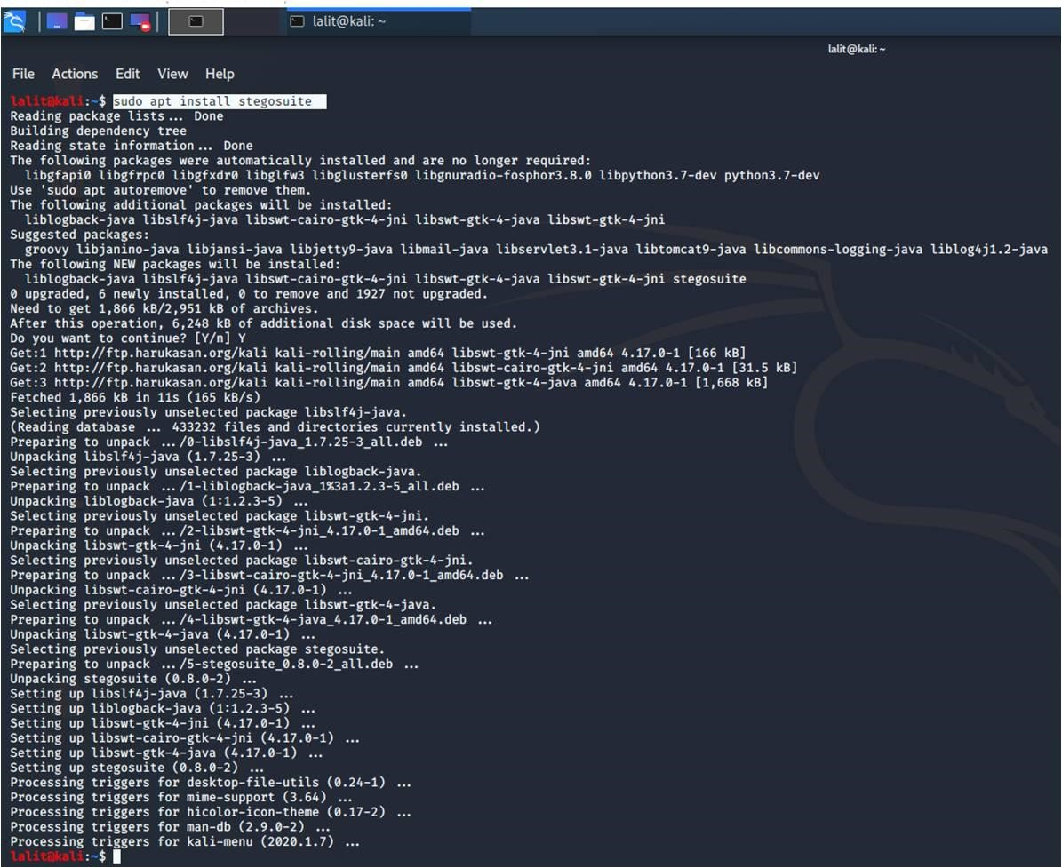

Now after complete execution of the above commands. To run Stegosuite simply type “stegosuite” in terminal.

### stegosuite

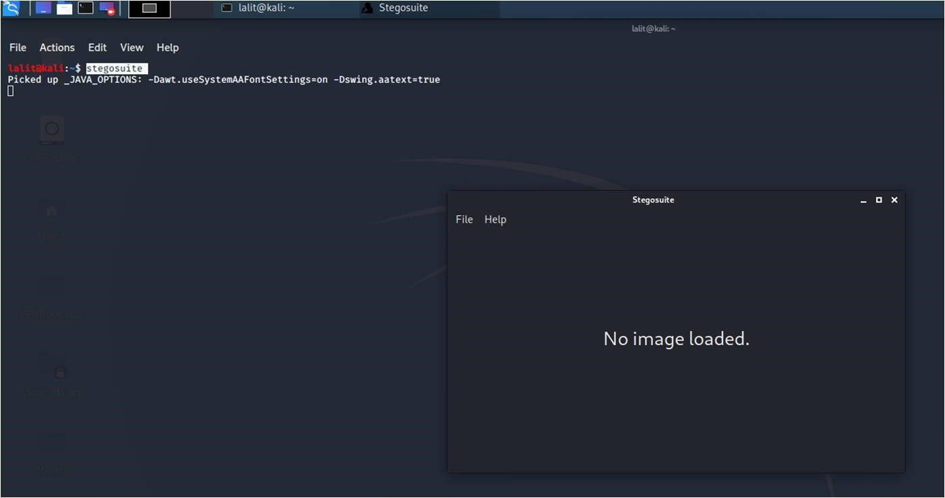

**Embed data:**

1. *stegosuite* command will open the Stegosuite window.
2. Click on the file in the Stegosuite window to select the image file.
3. Type the secret message or select the text files you want to embed in the image.
4. Choose any password and after that click on the Embed button.

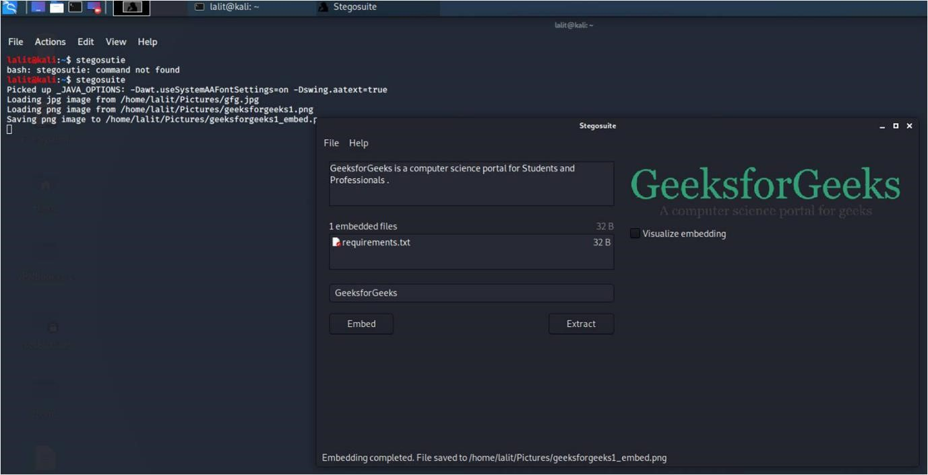

In the above image, We are hiding a secret message as well as a text file. Then we just need to click on Embed and Steganography will be done.

**Extract Data:**

1. Click on the file in Stegosuite window to select the stego file you want to extract hidden information from
2. Type the password and click the extract button
3. The hidden data will be extracted

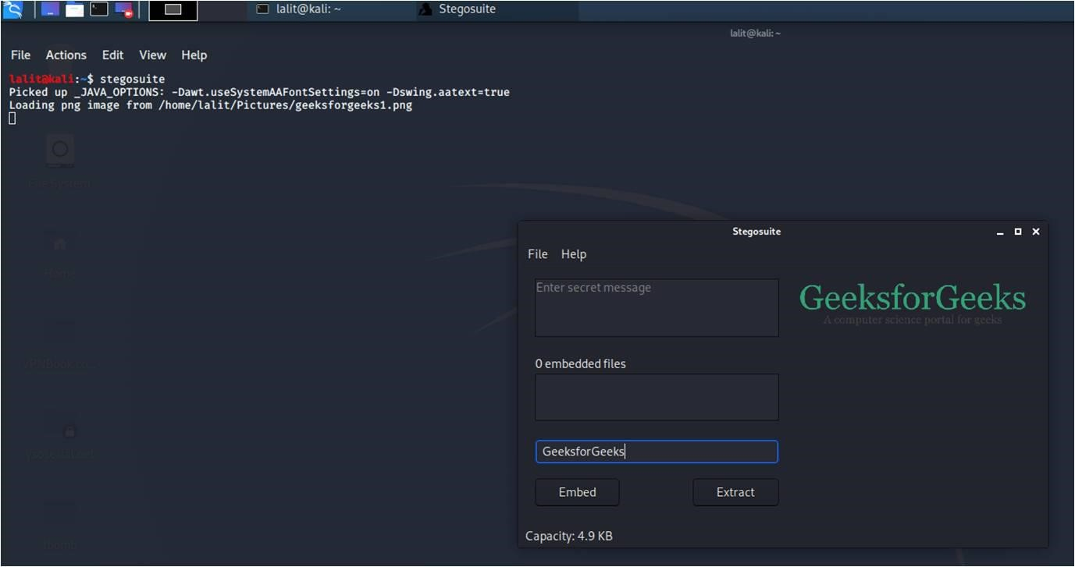

Type your Password and click on Extract. The hidden message and text files will be visible now.

# HTTRACK

**AIM:**

To familiarize the cyber forensic tool httrack

**DESCRIPTION:**

HTTrack is an easy-to-use offline browser utility. It allows you to download a World Wide Website from the Internet to a local directory, building recursively all directories, getting html, images, and other files from the server to your computer. HTTrack arranges the original site's relative link-structure. Simply open a page of the "mirrored" website in your browser, and you can browse the site from link to link, as if you were viewing it online. HTTrack can also update an existing mirrored site, and resume interrupted downloads. HTTrack is fully configurable, and has an integrated help system.

WinHTTrack (Windows release of HTTrack) and WebHTTrack (Linux/Unix

release of HTTrack) are very similar, but not exactly identical. You may encounter minor differences (in the display, or in various options) between these two releases. The engine behind these two release is identical.

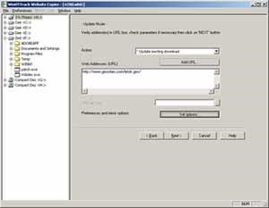

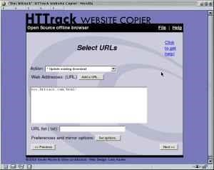

**PROCEDURE:**

Step 1: Choose a project name and destination folder

* Change the destination folder if necessary

It is more convenient to organize all mirrors in one directory, for example My Web Sites.If you already have made mirrors using HTTrack, be sure

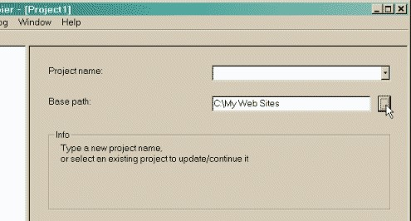

* Select a new project name OR select an existing project for update/retry



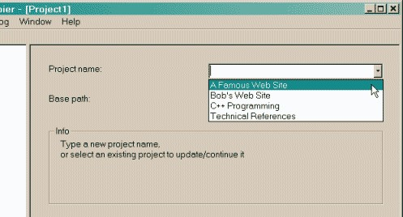

* Click on the NEXT button

Step 2 : Fill the addresses

Select an action,the default action is Download web sites

* + *Download web site(s)* Will transfert the desired sites with default options
  + *Download web site(s) + questions* Will transfert the desired sites with default options, and ask questions if any links are considered as potentially downloadable
  + *Get individual files* Will only get the desired files you specify (for example, ZIP files), but will not spider through HTML files
  + *Download all sites in pages* (multiple mirror) Will download all sites that appears in the site(s) selected. If you drag&drop your boormark file, this option lets you mirror all your favorite sites
  + *Test links in pages* (bookmark test) Will test all links indicated. Useful to check a bookmark file
  + *Continue interrupted download* Use this option if a download has been interrupted (user interruption,crash..)
  + *Update existing download* Use this option to update an existing project. The engine will recheck the complete structure, checking each downloaded file for any updates on the web site.

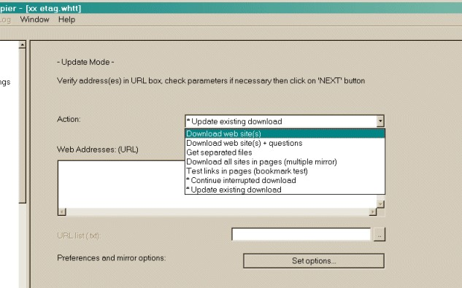

* Enter the site's addresses

You can click on the *Add a URL* button to add each address, or just type them in the box

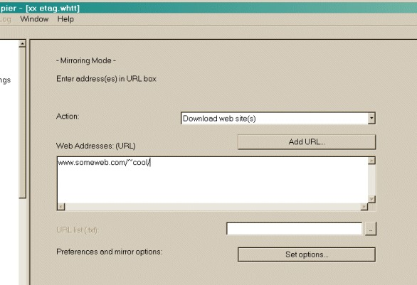

* You may define options by clicking on the [**Set options**](https://www.ucalgary.ca/utils/httrack-3.40.3/html/step9.html) button.You can define filters or download parameters in the option panel.
* You may also add a URL by clicking on the [**Add a URL**](https://www.ucalgary.ca/utils/httrack-3.40.3/html/addurl.html) button.This option lets you define additional parameters (login/password) for the URL, or capture a complex URL from your browser.
* Click on the NEXT button.

Step 3 : Ready to start

* If you want, you may connect immediately or delay the mirrorIf you don't select anything, HTTrack will assume that you are already connected to the

Internet and that you want to start the mirror action now

* + Connect to this provider, you can select here a specific provider to connect to when begining the mirror if you are not already connected to the Internet.
  + Disconnect when finished ,Click on this checkbox to ask httrack to disconnect the network when mirror is finished.
  + Shutdown PC when finished,Click on this checkbox to ask httrack to shutdown your computer when mirror is finished.
  + On Hold,you can enter here the time of the mirror start. You can delay up to 24 hours a mirror using this feature.
* Click on the FINISH button

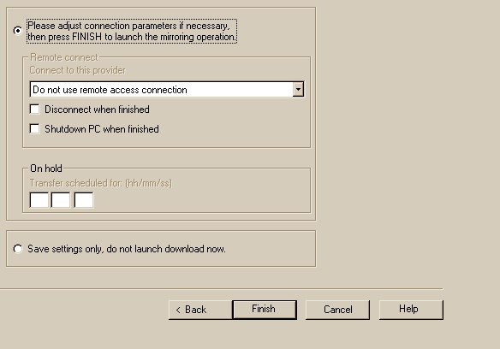

Step 4 : Wait

Wait until the mirror is finishing,You can cancel at any time the mirror, or cancel files currently downloaded for any reasons (file too big, for example)Options can be changed during the mirror: maximum number of connections, limits...

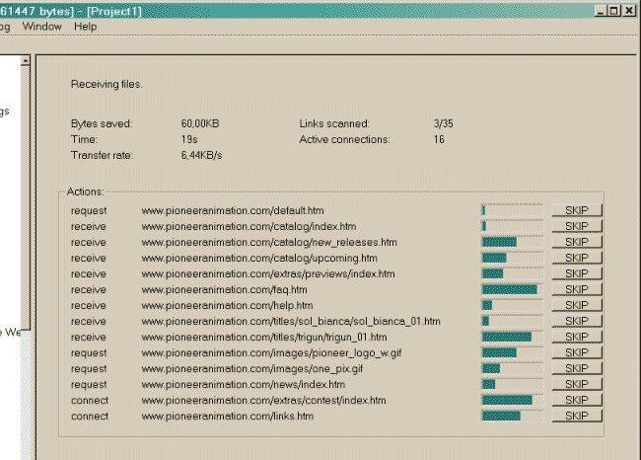

Step 5 : Check the result ,You may check the error log file, which could contain useful information if errors have occurred.

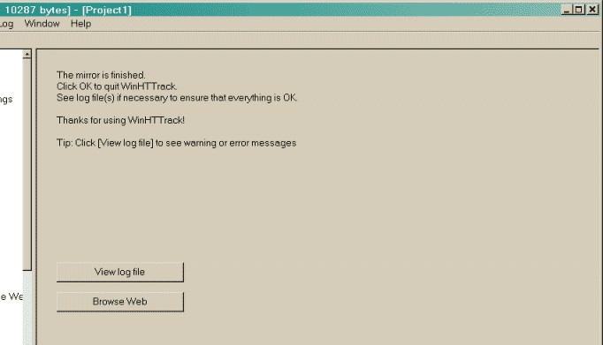

# ADVANCED IP-SCANNER

**AIM:** To familiarize the ip-scanner in windows os.

**DESCRIPTION:**

Advanced IP Scanner is fast and free software for network scanning. It will allow you to quickly detect all network computers and obtain access to them. With a single click, you can turn a remote PC on and off, connect to it via [Radmin,](https://www.radmin.com/) and much more.

Reliable and free network scanner to analyze LAN. The program shows all network devices, gives you access to shared folders, provides remote control of computers (via RDP and Radmin), and can even remotely switch computers off. It is easy to use and runs as a portable edition. It should be the first choice for every network admin.

Advanced IP Scanner is a powerful and user-friendly Windows application that allows you to quickly and easily scan your network and detect all connected devices. With this app, you can find all IP addresses and MAC addresses in your local network, as well as their device names and manufacturers.

Advanced IP Scanner is perfect for network administrators and IT professionals who need to monitor and manage their network. With its intuitive interface and powerful scanning capabilities, you can quickly identify any unauthorized devices and protect your network from potential security threats.

## Functions

✓ **Save List**

This function allows you to save the list of computers from the current tab. The file is saved in .xml, .html, .csv formats.

To perform this operation :

### Shortcut menu - "Save selected ";

***Main menu - "File → Save as… ".***

* **Load List**

This function allows you to load the list of computers from the specified file into the "Favorites" list. Only .xml files can be used for loading.

To perform this operation :

***Main menu - "File → Load Favorites ".***

* **Toolbar – Class "C" Subnetwork**

This allows you to set the starting IP-address as ***.***.***.0 and the end IP-address as ***.***.***.255, where "***" are the current values of the entered IP-address.

To perform this operation :

***Toolbar - "class "C" subnetwork" button***.

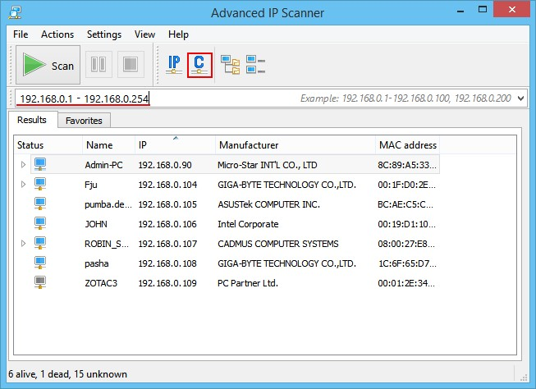

* **Toolbar – Current Computer Subnetwork**

This function allows you to set the starting and ending IP-addresses as per the subnetwork mask of your computer.To perform this operation **:**

***Toolbar - "IP" button.***

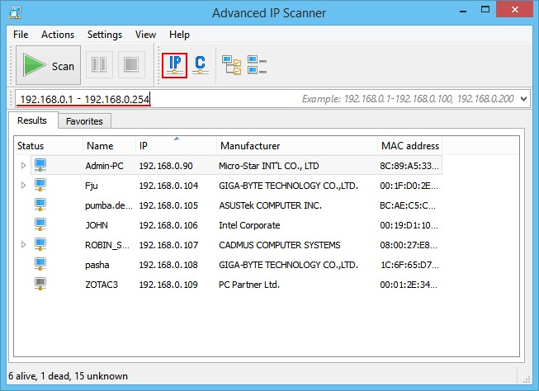

* **Tools – Ping**

Starts a terminal window with the ping command to a remote computer.To perform this operation **:**

***Shortcut menu - "Tools → Ping";***

***Main menu - "Actions → Tools → Ping".***

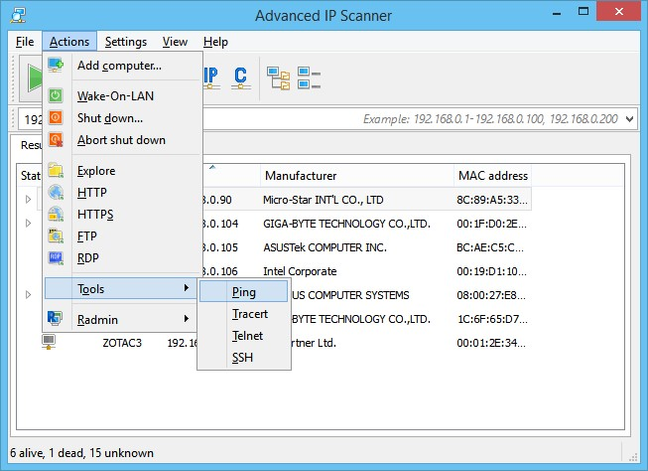

* **Tools - Tracert**

Starts a terminal window with the tracert command to trace the route to the remote computer.To perform this operation :

***Shortcut menu - "Tools → Tracert";***

***Main menu - "Actions → Tools → Tracert".***

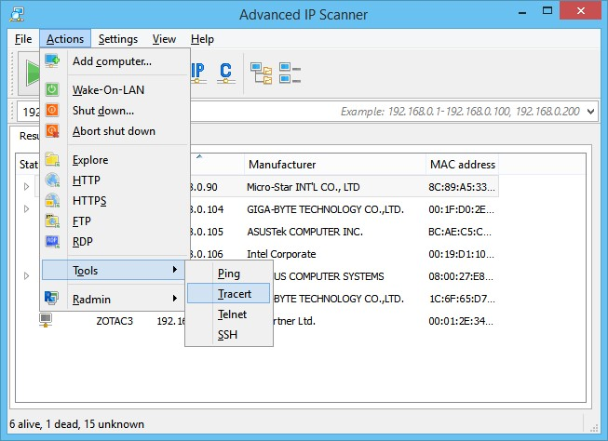

* **Tools - Telnet**

Starts a terminal connected to a selected computer on the standard Telnet port.To use the telnet client (other than default client) you need to specify a path to it in "Settings → Options… → Misc".To perform this operation :

### Shortcut menu - "Tools → Telnet";

***Main menu - "Actions → Tools → Telnet".***

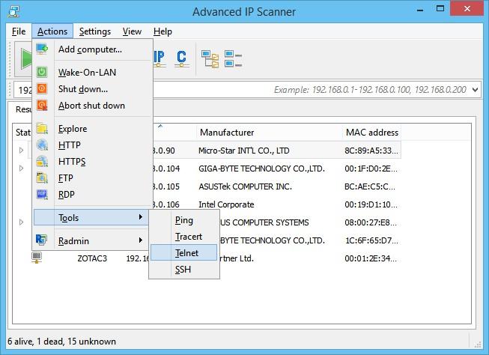

* **Tools - SSH**

Allows you to connect to the selected computer via SSH-Clent selected by the user. SSHclient is specified in the "Settings → Options... → Misc".To perform this operation :

***Shortcut menu - "Tools → SSH";***

***Main menu - "Actions → Tools → SSH".***

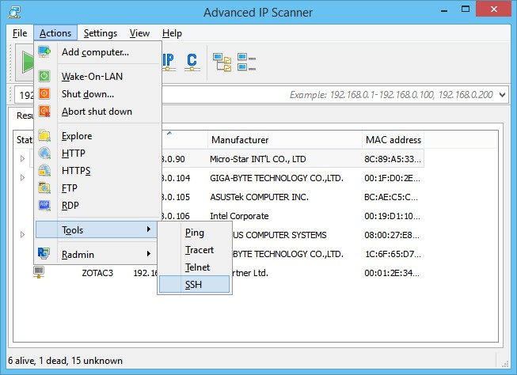

* **Options - Performance**

The "High-accuracy scanning (lower speed)" option allows you to scan each computer several times. This improves the accuracy of the scan, but takes more time.The scanning rate slider allows you to smoothly change the speed of the scan, as well as the processor and network load.Click on the "OK" button to save changes to the settings.To perform this operation :

***Main menu - "Settings → Options → Performance ".***

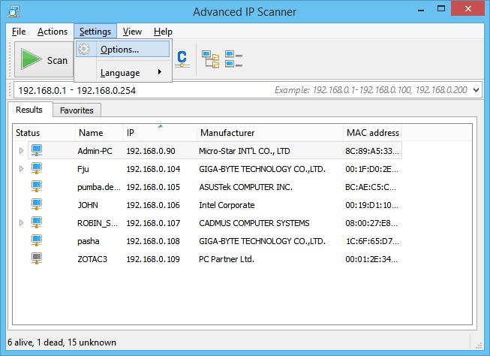

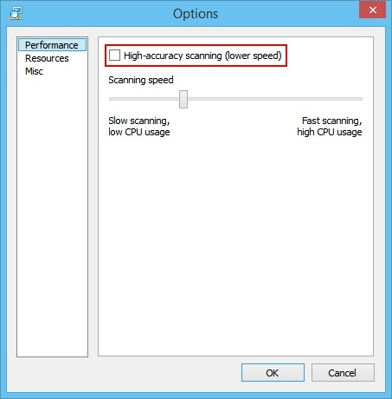

* **Options - Resources**

The Resources section allows you to select the resources to be scanned. The smaller the number of resources selected, the less time the scanning process will take.Click on the "OK" button to save changes to the settings.To perform this operation :

***Main menu - "Settings → Options → Resources ".***



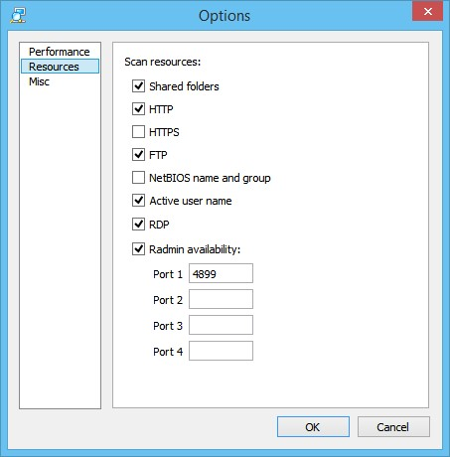

* **Options - Misc**

The Misc settings section of the program allows you to enable automatic checks for updates, and specify the use of SSH client, Telnet client, FTP client, HTTP client. You can also enable the use of the portable version of Radmin Viewer and specify the path to it.In this section, you

can enable the table colors’ alternation.To perform this operation :

***Main menu - "Settings → Options → Misc ".***

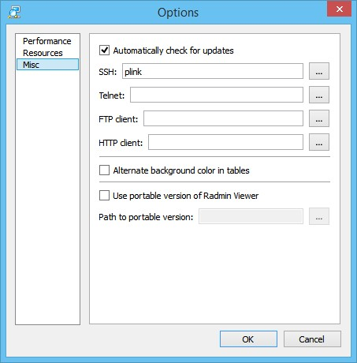

* **Shut Down Computer**

This function allows you to try shutting down the selected computer remotely (if you are authorized to do so).To perform this operation :

***Main menu - "Actions → Shut down ";***

***Shortcut menu - "Shut down ";***

***Toolbar - "Shut down" button (additional buttons can be added to the toolbar from the main menu under "View" section).***

After pressing the "Shut down" button, the dialog box shown below will appear on the screen, where the following operations can be carried out by selecting the corresponding options:

* + ***"Forced shutdown"*** – shut down/reload the computer, even if some programs are still running and warning messages about the possible loss of unsaved data in case of restart appear;
  + ***"Reboot"*** – reboot the computer instead of turning off;
  + ***"Message"*** – warns the user that "Your computer will restart in N seconds".

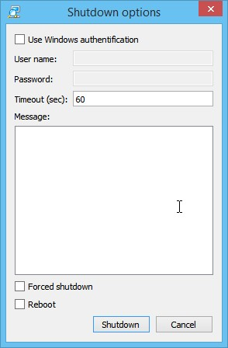

* **Aborting Remote Shut Down**

This function allows you to cancel the remote shut down of selected computers.To perform this operation :

***Main menu - "Actions → Abort shut down ";***

***Shortcut menu - "Abort shut down ";***

***Toolbar - "Abort shut down" button (additional buttons can be added to the toolbar from the main menu under "View" section).***

* **Wake-on-LAN**

This function sends the "Wake-On-LAN" command to selected computers. This command will only be sent to computers where the MAC-addresses have been identified.To perform this operation :

***Main menu - "Actions → Wake-on-LAN";***

***Shortcut menu - "Wake-On-LAN";***

***Toolbar - "Wake-On-LAN" button (additional buttons can be added to the toolbar from the main menu under "View" section).***

* **Browse Computer**

This function will open Windows Explorer showing the selected computer.To perform this operation :

***Main menu - "Actions → Explore ";***

***Shortcut menu - "Explore ";***

***Toolbar - Toolbar - "Explore" button (additional buttons can be added to the toolbar from the main menu under "View" section).***

* **HTTP Connection**

Allows you to connect to the computer via HTTP protocol using a browser selected by the user.

HTTP client is specified in "Settings → Options… → Misc". If the HTTP client is not specified, the default client is used.To perform this operation :

***Main menu - "Actions → HTTP";***

***List of computers - double click on the computer icon, double click "HTTP" for connection;***

***Toolbar - HTTP button (additional buttons can be added to the toolbar from the main menu under "View" section).***

* **HTTPS Connection**

Allows you to connect to the computer via HTTPS protocol using a browser selected by the user. The same client is used to connect to the HTTP protocol.To perform this operation:

***Main menu - "Actions → HTTPS";***

***List of computers - double click on the computer icon, double click "HTTPS" for connection;***

***Toolbar - HTTPS button (additional buttons can be added to the toolbar from the main menu under "View" section).***

* **FTP Connection**

This function allows you to connect to the selected computer via FTP protocol using a browser. You can specify a different FTP client under "Settings → Options… → Misc" section.To perform this operation :

***Main menu - "Actions → FTP";***

***List of computers - double click on the computer icon, double click "FTP" for connection;***

***Toolbar - FTP button (additional buttons can be added to the toolbar from the main menu under "View" section).***

* **Connection Via Radmin**

This function starts [Radmin](https://www.radmin.com/) to connect to the selected computer.To perform this operation :

***Main menu - "Actions → Radmin";***

***Shortcut menu - "Radmin";***

***List of computers - double click on the computer icon, double click "Radmin";***

***Toolbar - you can add buttons to your toolbar in the main menu under "View" section.***

* **Remote Desktop Protocol Connection**

RDP (Remote Desktop Protocol) developed by Microsoft provides a graphical interface that allows a user to work on another computer over a network connection.Allows you to connect to a selected computer via RDP.To perform this operation :

***Main menu - "Actions → RDP";***

***Shortcut menu - "RDP";***

***List of computers - double click on the computer icon, double click "RDP";***

***Toolbar - RDP button (you can add buttons to your toolbar in the main menu under "View" section).***

**PROCEDURE:**

### ➢ Network Scanning

* Enter your range of IP addresses ("IP" button in the toolbar will help you to set the IPaddress range of your network).

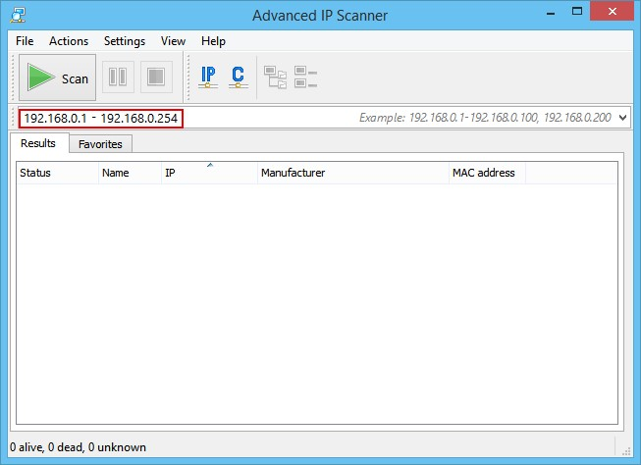

* Click "Scan". Once the scanning process has been completed you will get a list of the computers in the network.

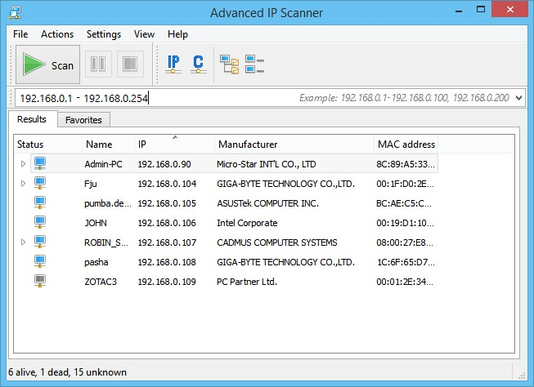

➢ **Creating a Favorites List of Computers for Regular Use**

1. Scan the network.
2. Select the required computers and click the "Add to "Favorites" option in the shortcut menu.

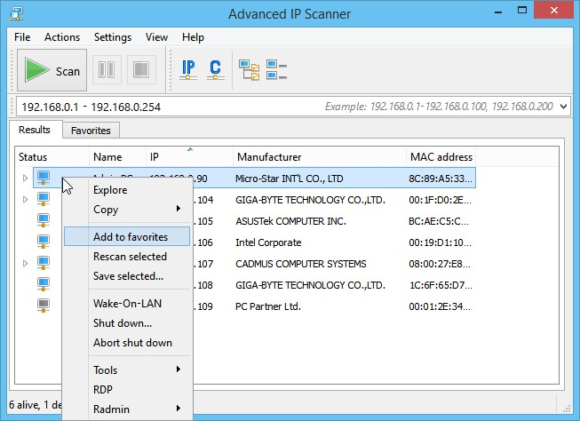

1. You can now work on these computers by using the "Favorites" tab.

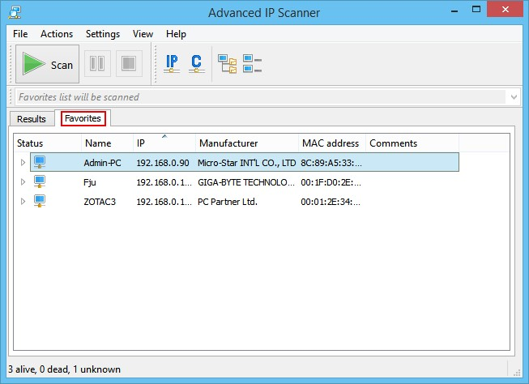

1. You can also add a new computer to "Favorites" by selecting "Actions → Add computer…" in the menu and entering your computer’s information in the dialog box.

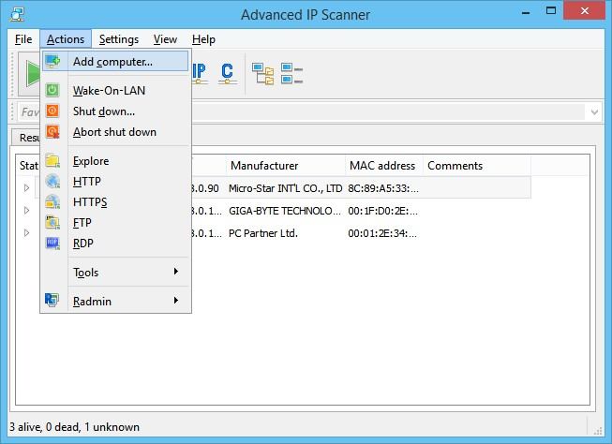

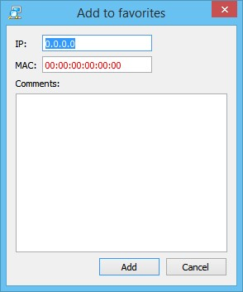

You can also save the list of computers from the "Favorites" tab. The file will be saved in .xml, .html, .csv formats.

**To perform this operation:**

* + **Shortcut menu** - "Save selected ";
  + **Main menu** - "File → Save as… ".

To load a list of computers from a file to "Favorites", follow these steps : **Main menu** - "File → Load Favorites ".

### ➢ Radmin and Advanced IP Scanner

[Radmin](https://www.radmin.com/) is one of the best remote-control software for Windows, allowing you to work at a remote computer as if you were sitting right in front of it, using a standard graphical interface.

1. Select the required computer from the results of the network scan or from the "Favorites" tab.
2. If Radmin Server is found on the computer, you can connect to it by selecting the corresponding type of Radmin connection in the shortcut menu. To connect to a remote computer, you need to install Radmin Viewer. You can download it for free at: [www.radmin.com/download/.](https://www.radmin.com/download/)

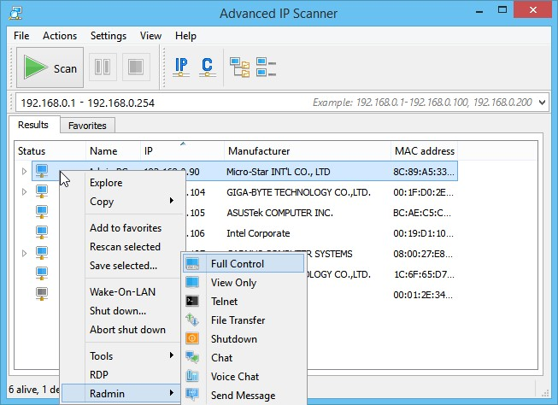 You can also use the portable version of Radmin Viewer. Enable "Use portable version of Radmin Viewer" in "Settings → Options… → Misc" and specify the path to it.

**Netstat Command in Linux**

Linux netstat command stands for **Network statistics**. It displays information about different interface statistics, including open sockets, routing tables, and connection information. Further, it can be used to displays all the socket connections (including TCP, UDP). Apart from connected sockets, it also displays the sockets that are pending for connections. It is a handy tool for network and system administrators.

In computing, the netstat command is a command-line network utility that shows network connections for TCP (both outgoing and incoming), several network interfaces (softwaredefined network interface or network interface controller), network protocol statistics, and routing tables. It's available on Plan 9, Unix, Inferno, and Unix-like OSes, including BSD, Solaris, Linux, and macOS. Also, it's available on IBM OS/2 and Microsoft Windows NT-based OSes, including Windows 10, Windows 8, Windows 7, Windows Vista, and Windows XP.

In the network, t is used to find problems and determine the traffic as a performance measurement. This program is almost obsolete on Linux, although still added in several distributions.

The netstat command is superseded by ***"s"*** on Linux. The ip route command is the replacement of the netstat -r command, and the ip maddr command is the replacement of the netstat -i command, each of which is suggested instead.

Netstat gives statistics for below: o **Proto:** Proto is the protocol name (UDP or TCP).

* **Local Address:** Local Address specifies the local computer's IP address and port number being utilized. The local computer's name related to the IP address and the port name is displayed unless the parameter, i.e., -n, is mentioned. An asterisk (*) is displayed for the host when the server is active (listening) in every interface. The port number is displayed as an asterisk if the port isn't established yet.
* **Foreign Address:** The port number and IP address of the remote computer to which a socket is linked. The names that relate to the IP address and all ports are displayed unless the parameter, i.e., -n, is mentioned. The port number is displayed as an asterisk if the port isn't established yet.
* **State:** Represents the TCP connection state. Several possible states are available, including TIME_WAIT, SYN_SEND, SYN_RECEIVED, LISTEN, LAST_ACK, FIN_WAIT_2, FIN_WAIT_1, ESTABLISHED, CLOSED, and CLOSE_WAIT.

Some of the netstat commands and their description are mentioned below:

|  |  |
| --- | --- |
| **Command** | **Description** |
| **netstat -a** | Represents every socket, both non-listening and listening, and every protocol, like UDP, TCP, etc. |
| **netstat -at** | Represents TCP connections only (-au represents UDP connections only). |
| **netstat -ant** | Represents every TCP connection without DNS resolution (rather than displays IP addresses). |
| **netstat -al** | Displays listening sockets only. |
| **netstat -aep** | Displays PID and to which function all sockets belong; e includes extra information like the user. Execute as root to check every PID. |
| **netstat -s > file2.txt** | Displays network statistics. |
| **netstat -i** | Shows a table of every network interface. Include -e to receive the result, which is the same as ifconfig. |
| **netstat -r** | Displays the information on kernel routing. It is a similar result as route -e. |
| **netstat -ct** | Shows TCP connections regularly. |
| **netstat -g** | Shows the information of multicast group membership for IPv6 and IPv4. |
| **netstat -atnp | grep**  **ESTA** | Shows every "established" connection of TCP currently. |
| **netstat -lntu** | Shows every service listening UDP and TCP, every free open port over the local device. |

Syntax:

The netstat command supports various command-line options. The basic syntax of the netstat command is as follows:

## netstat

It supports multiple command-line options to print information about the [Linux](https://www.javatpoint.com/linux-tutorial) networking subsystem. The output is controlled by the first argument. Let's see the list of the first arguments:

**(none):** If no option is specified, it will execute the default command that displays a list of open sockets of all configured address families.

**--route, -r:** It is used to print the kernel routing tables. The "netstat -r" command and "route e" command will produce the same output.

**--groups, -g:** It is used to display multicast group membership information different IP versions (Ipv4 and IPV6).

**--interfaces, -i:** It is used to display all network interfaces.

**--masquerade, -M:** It displays masqueraded connections.

**--statistics, -s**: This option displays the summary statistics for each protocol.

**--verbose, -v**: It is used to display the detailed output. It is a handy tool for displaying the details about unconfigured address families.

**--wide, -W:** It is used as an output not to reduce the IP address as necessary. It is still optional not to break existing scripts.

**--numeric-hosts**: It is used to display numerical host addresses; it does not affect the resolution of port or user names.

**--numeric-ports:** It is used to display numerical port numbers, it does not affect the properties and objects of host or user names.

**--numeric-users**: It is used to display numeric user Ids, it does not affect the resolution of host or port names.

**--numeric, -n:** It is used to display numeric addresses alternatively defining symbolic hosts, ports, or usernames.

**--protocol=family, -A**: It is used to specify the address families for which connections are to be displayed. The address families are a comma (',') separated like Inet, inet6, Unix, ax25, Netrom, Econet, Ipx, DDP, and Bluetooth.

**-c, --continuous**: It is used to display the selected information continuously for every second.

**-e, --extend:** It is used for extended output. This option can be used twice for maximum detail. **-o, --timers**: It is used to include networking timers related information.

**-p, --program:** It is used to display the PID and name of the process to the corresponding sockets.

**-l, --listening:** It is used to display only listening sockets.

**-a, --all:** It is used to display both sockets (i.e., listening and non-listening). By specifying the '--interfaces' option, we can list the interfaces that are not up.

**-F:** It is used to display the routing information from the FIB.

**-C:** It is used to display the routing information from the route cache.

Installation of the netstat command

If the netstat command is not installed on your machine, it will display the traditional Linux installation error message "Command 'netstat' not found."

To install it, execute the below command:

### sudo apt install net-tools

The above command will ask for the administration password to install the command. If it is successfully installed, it will produce the output as follows:

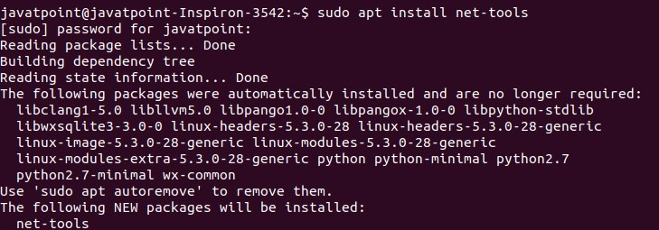

Examples of the netstat command

Let' see the following examples of the netstat command:

o Display All Connections o Display only TCP or UDP connections o Disable reverse DNS lookup for faster output o Display only listening connections o Display Pid and Uid o Display Statistics o Display kernel routing information o Display network interfaces o Display netstat output continuously o Display multicast group information

### Display All Connections

The '-a' option is used to display all the existing connections. Execute the netstat command as follows:

#### netstat- a

The above command will list all the existing connections. Consider the below output:

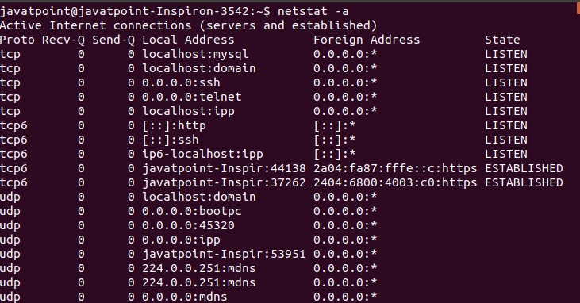

### Display only TCP or UDP Connections

We can list only the TCP or UDP connections. To display only the TCP connection, execute the command with the 't' option as follows:

#### netstat -at

The above command will list all the TCP connections. Consider the below output:

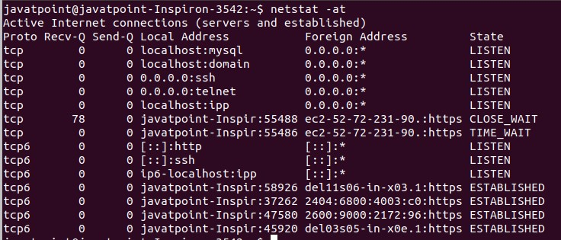

To display only UDP connection, execute it with 'u' option as follows:

#### netstat -au

The above command will list all the UDP connections. Consider the below output:

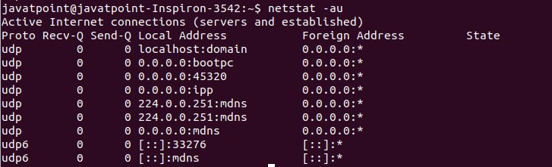

### Disable Reverse DNS Lookup for Faster Output

The default behavior of the netstat command finds out the hostname for each IP address by a reverse DNS lookup. It causes the slowdowns in output. If we don't want to know the hostname, then disable the reverse DNS lookup by suppressing the 'n' option with it: Consider the below command:

#### netstat -ant

The above command will disable the reverse DNS lookup and display all the TCP connections. Consider the below output:

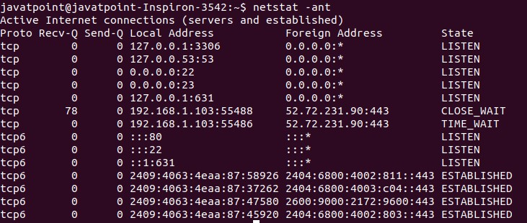

### Display only Listening Connections

The listening connections are such connections that are available for connection requests. Any network process keeps an open port for the listening incoming connection requests. These connections can be listed by executing the below command:

#### netstat -tnl

The above command will list all the listening connection for TCP connections. Consider the below output:

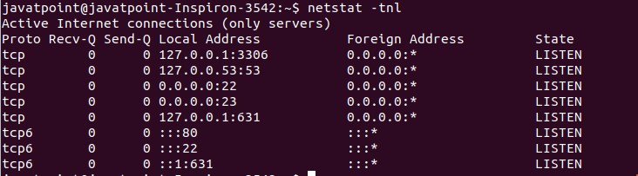

### Display Pid and Uid

While checking the network statistics, it is sometimes vital to know the Pid and Uid for a particular connection or user. The Pid and Uid can be listed by executing the 'p' option. Execute the below command:

#### sudo netstat -nlpt

The above command will list all the Pid for the TCP connections. It is necessary to execute this command with sudo privilege. Otherwise, it will not display the Pid. Consider the below output:

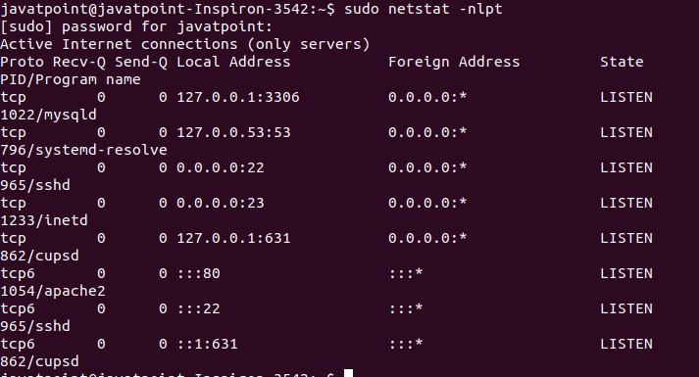

***Display Statistics*** netstat command is also a handy tool for displaying the network statistics such as no packets transmitted and received by a protocol. To display the network statistics, execute the command with the '-s' option as follows:

#### netstat -s

The above command will display the network statistics. Consider the below output:

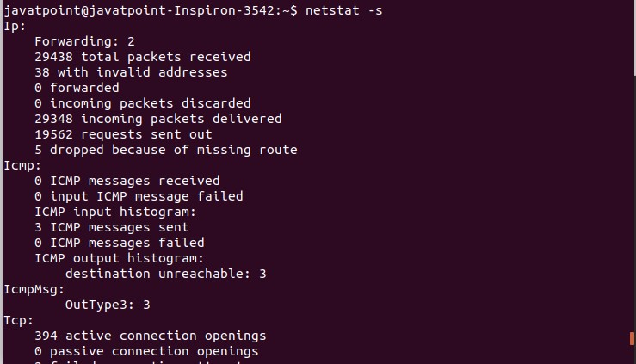

### Display kernel Routing Information

The 'r' option is used to display the kernel routing information. It will display the same output as route command. To display the routing information, execute the command as follows:

#### netstat -rn

The above command will display the routing information. The 'n' option will disable the hostname lookup. Consider the below output:

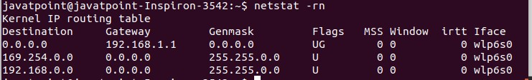

### Display Network Interfaces

We can also display information about the network interfaces by using the netstat command.

To display the network interfaces, execute the command with 'i' option as follows:

#### netstat -i

The above command will list the network interfaces and related information. Consider the below output:

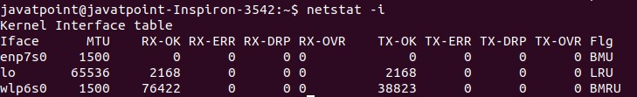

### Display netstat Output Continuously

To display the netstat output continuously, execute the command with the 'c' option as follows:

#### netstat -ct

The above command will display the TCP connections continuously. Consider the below output:

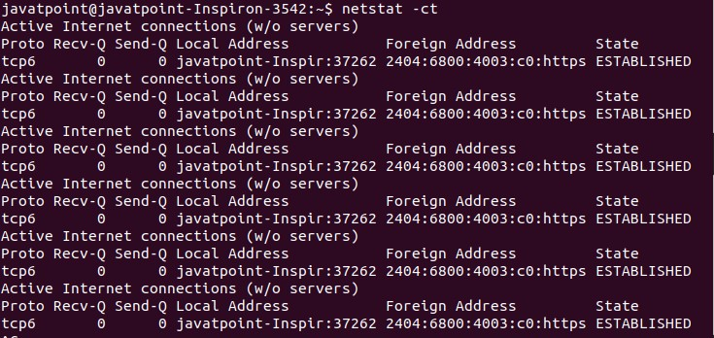

### Display Multicast Group Information

The 'g' option is used to display the multicast group information. To print the details for [Ipv4 and Ipv6,](https://www.javatpoint.com/ipv4-vs-ipv6) execute the command as follows:

#### netstat -g

The above command will display the multicast group information. Consider the below output:

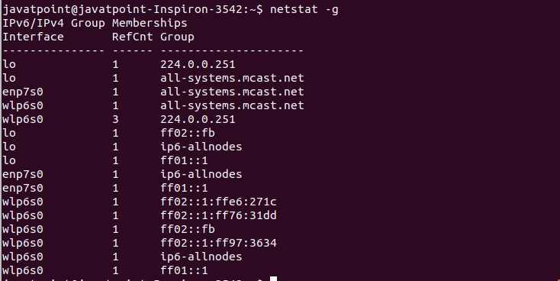

### Install Net-Tools in Linux

The netstat command is a part of a package called net-tools. We get the net-tools package using the following command in Ubuntu:

***$ sudo apt install net-tools***

### Check Netstat Version

Upon the installation process, we can check the installed Netstat version using the following command:

***$ netstat -v***

### Show Routing Table

The netstat command displays the routing table information on the command line. If we want to check the routing table, we can use the -nr option with Netstat; it will display the kernel routing table in a similar form to that route does. We can run the following command:

#### $ netstat -nr

The -nr flag permits Netstat to show addresses separated by dots rather than applying symbolic address titles.

### Show Network Connection

The netstat command has a variety of options to view passive and active sockets. Active TCP, Unix, RAW, and UDP socket connections are mentioned by the -x, -w, -u, and -t options, respectively.

We can run the following command:

***$ netstat -ta***

### Show Network Services

We can execute the below command to see a network list, their related ports, and their current states:

***$ netstat -pnltu***

### Show every listening port of the UDP and TCP connection

We can see every UDP and TCP port by running the following command in the terminal window:

***$ netstat -a | more***

### Show every listening connection

We can use the netstat command with the -l option to list every active connection:

#### $ netstat -l